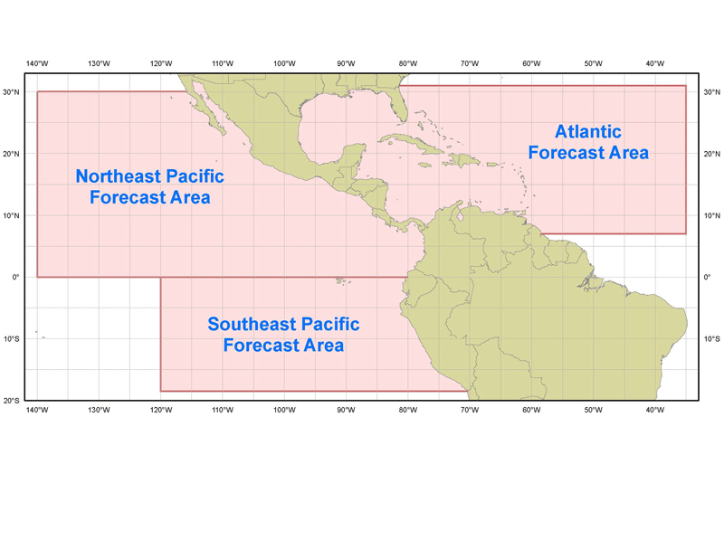   | HIGH SEAS FORECAST | 

- Purpose
The world’s oceans and seas are divided up into 16 separate regions known as “METAREAS” with different nations having responsibility for providing high seas marine forecasts for those waters. These high seas forecasts are used mainly by large transoceanic vessels but can also be used by smaller vessels or those on shorter voyages. The U.S. National Weather Service (through the National Hurricane Center, the Ocean Prediction Center, and the Honolulu Weather Forecast Office) has the responsibility to provide high seas marine forecasts for METAREAS IV, XII, and XVI, which cover most of the North Atlantic Ocean, North Pacific Ocean, and Southeast Pacific Ocean.

- Content
The National Hurricane Center issues three High Seas Forecasts for parts of METAREAS IV and XII and all of METAREA XVI. Each product is updated every 6 hours and includes a description of winds and waves for the current time (a nowcast) and a 24- and 48- hour forecast of the winds and waves, using a 20 knot threshold for the wind and an 8 feet threshold for the seas. Positions and intensities are also given for tropical cyclones out to the 120-hour forecast. Intermediate forecast times are given for rapidly changing weather events. The High Seas products also include updated descriptions of convection, particularly along the ITCZ. The products include marine warnings for gale, storm, hurricane force winds, and tropical cyclone-related conditions and can also include information on reduced visibility and other marine hazards.
- Coverage
The National Hurricane Center has 3 separate High Seas Forecasts:

- Atlantic Ocean (from 7°N to 31°N west of 35°W, including the Caribbean Sea and the Gulf of Mexico)
- Northeast Pacific Ocean (from the equator to 30°N east of 140°W)
- Southeast Pacific Ocean (from the equator to 18.5°S east of 120°W)

  - Issuance / Transmission
High seas products are transmitted under World Meteorological Organization (WMO) and NOAA Weather Wire Service (NWWS) headers as shown in the following table (alternate headers are for high seas products issued by the Ocean Prediction Center, which append the forecasts of the National Hurricane Center):

 | Primary Headers |  | Alternate Headers
 | WMO | NWWS | WMO | NWWS
Atlantic | FZNT02 KNHC | MIAHSFAT2 | FZNT01 KWBC | NFDHSFAT1
Northeast Pacific | FZPN03 KNHC | MIAHSFEP2 | FZPN01 KWBC | NFDHSFEP1
Southeast Pacific | FZPN04 KNHC | MIAHSFEP3

High seas products are issued on a regular six hourly schedule as shown below:

 | Issuance time in UTC
MIAHSFAT2 | 0430 | 1030 | 1630 | 2230
MIAHSFEP2 | 0430 | 1030 | 1630 | 2230
MIAHSFEP3 | 0515 | 1115 | 1715 | 2315

