 | HIGH WIND AND ASSOCIATED SEAS | 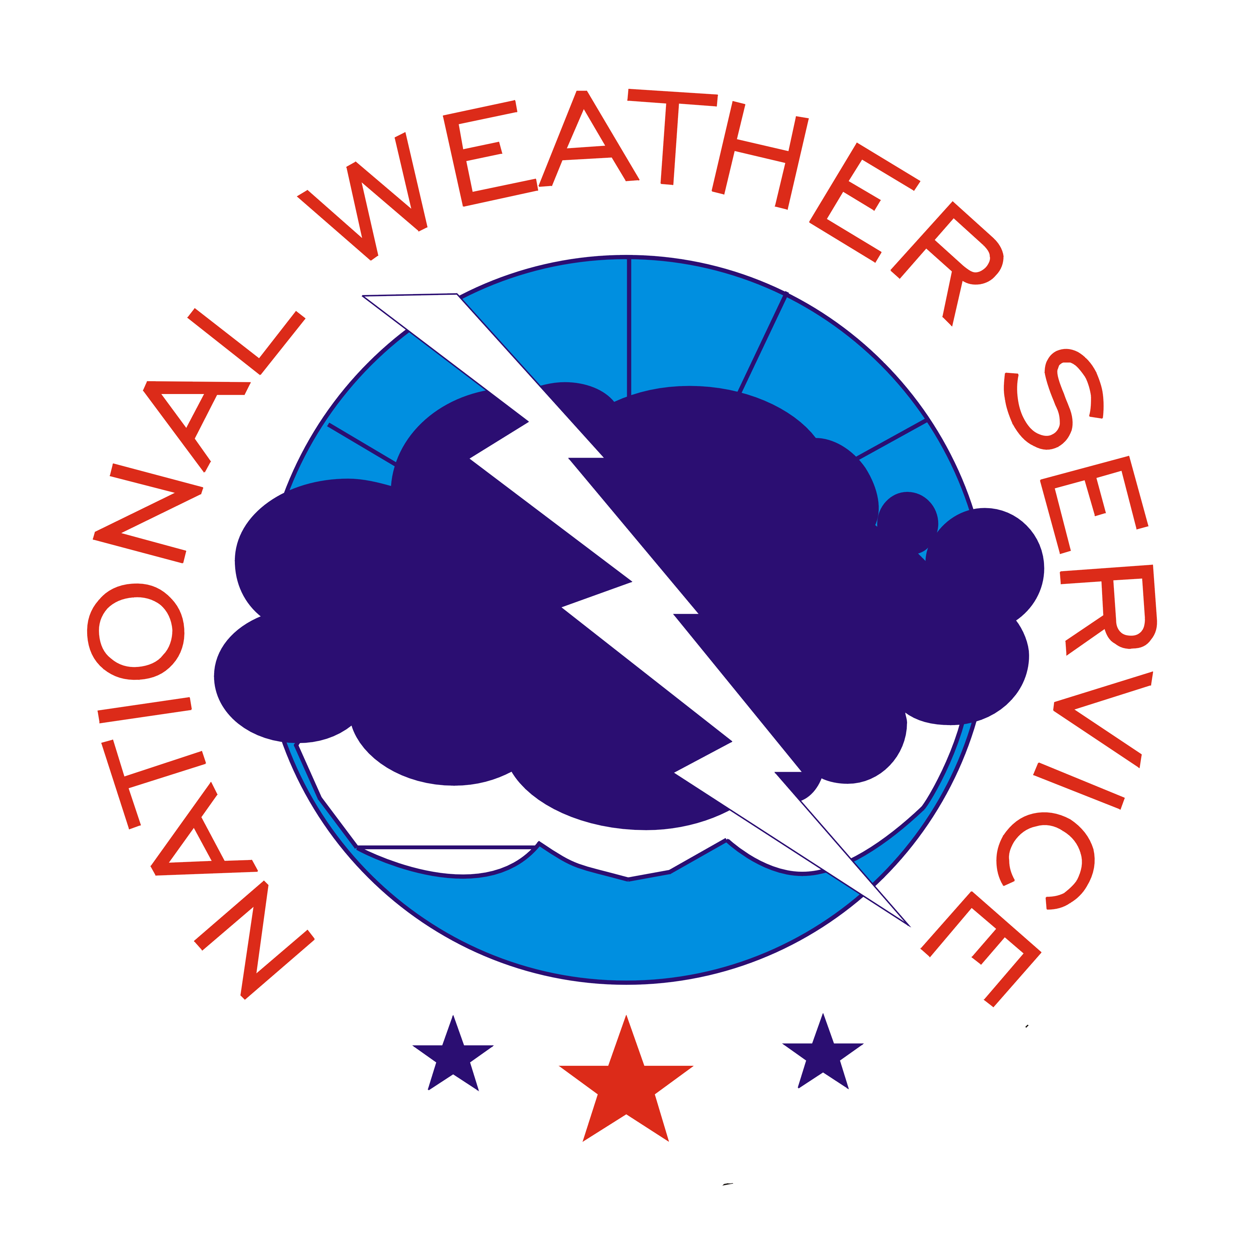

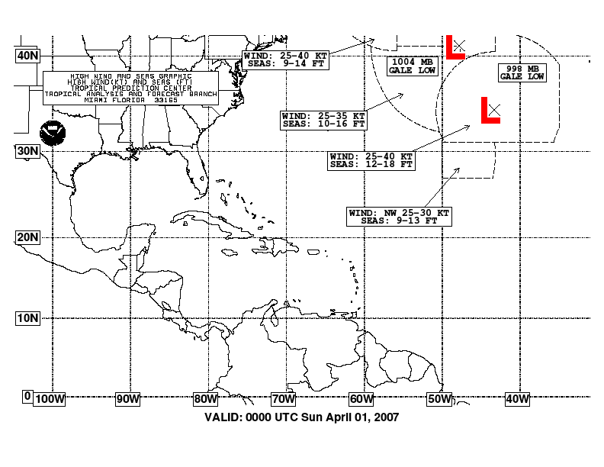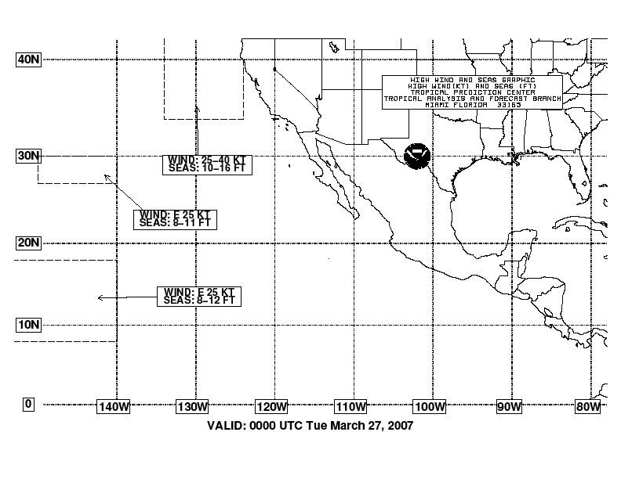
- Purpose
The high wind and associated seas graphic is produced by the National Hurricane Center to depict areas of high winds and related seas over the Atlantic and East Pacific waters between December 1 and May 14 (outside of hurricane season).

- Content
Areas depicted on the high wind and seas graphic are extracted from the high seas forecasts produced by the National Hurricane Center, the Ocean Prediction Center, and the Honolulu Weather Forecast Office. South of 30°N, areas are depicted for winds higher than 25 knots with the corresponding seas noted. North of 30°N, areas are depicted for winds of gale force (34 knots) or higher with the corresponding seas noted. Ranges in which the 25/34 knot thresholds are the upper limit (i.e. 25-35 knots) are included on the graphic.

- Coverage
The National Hurricane Center produces high wind and seas charts covering the following areas:

- Atlantic (from the equator to 40°N between 35°W and 100°W, including the Pacific east of 100°W)
- East Pacific (from the equator to 40°N between 80°W and 150°W)

- Issuance / Transmission
The high wind and associated seas graphics are transmitted by radiofax via Boston, New Orleans, and Pt. Reyes according to the following table:

 | Boston, MA  (Atlantic) |  | New Orleans, LA  (Atlantic) |  | Pt. Reyes, CA  (East Pacific)
Valid Time (UTC) | Transmission Time (UTC) | Filename | Transmission Time (UTC) | Filename | Transmission Time (UTC) | Filename
0000 | 0452 | PWEK89.TIF | 0735 | PWEK89.TIF | 0357 | PWFK88.TIF
0600 | 1028 | PWEK90.TIF | 1335 | PWEK90.TIF | 1009 | PWFK89.TIF
1200 | 1824 | PWEK91.TIF | 1935 | PWEK91.TIF | 1557 | PWFK90.TIF
1800 | 2228 | PWEK88.TIF | 0135 | PWEK88.TIF | 2214 | PWFK91.TIF
latest |  | PWEK11.TIF |  | PWEK11.TIF |  | PWFK11.TIF

