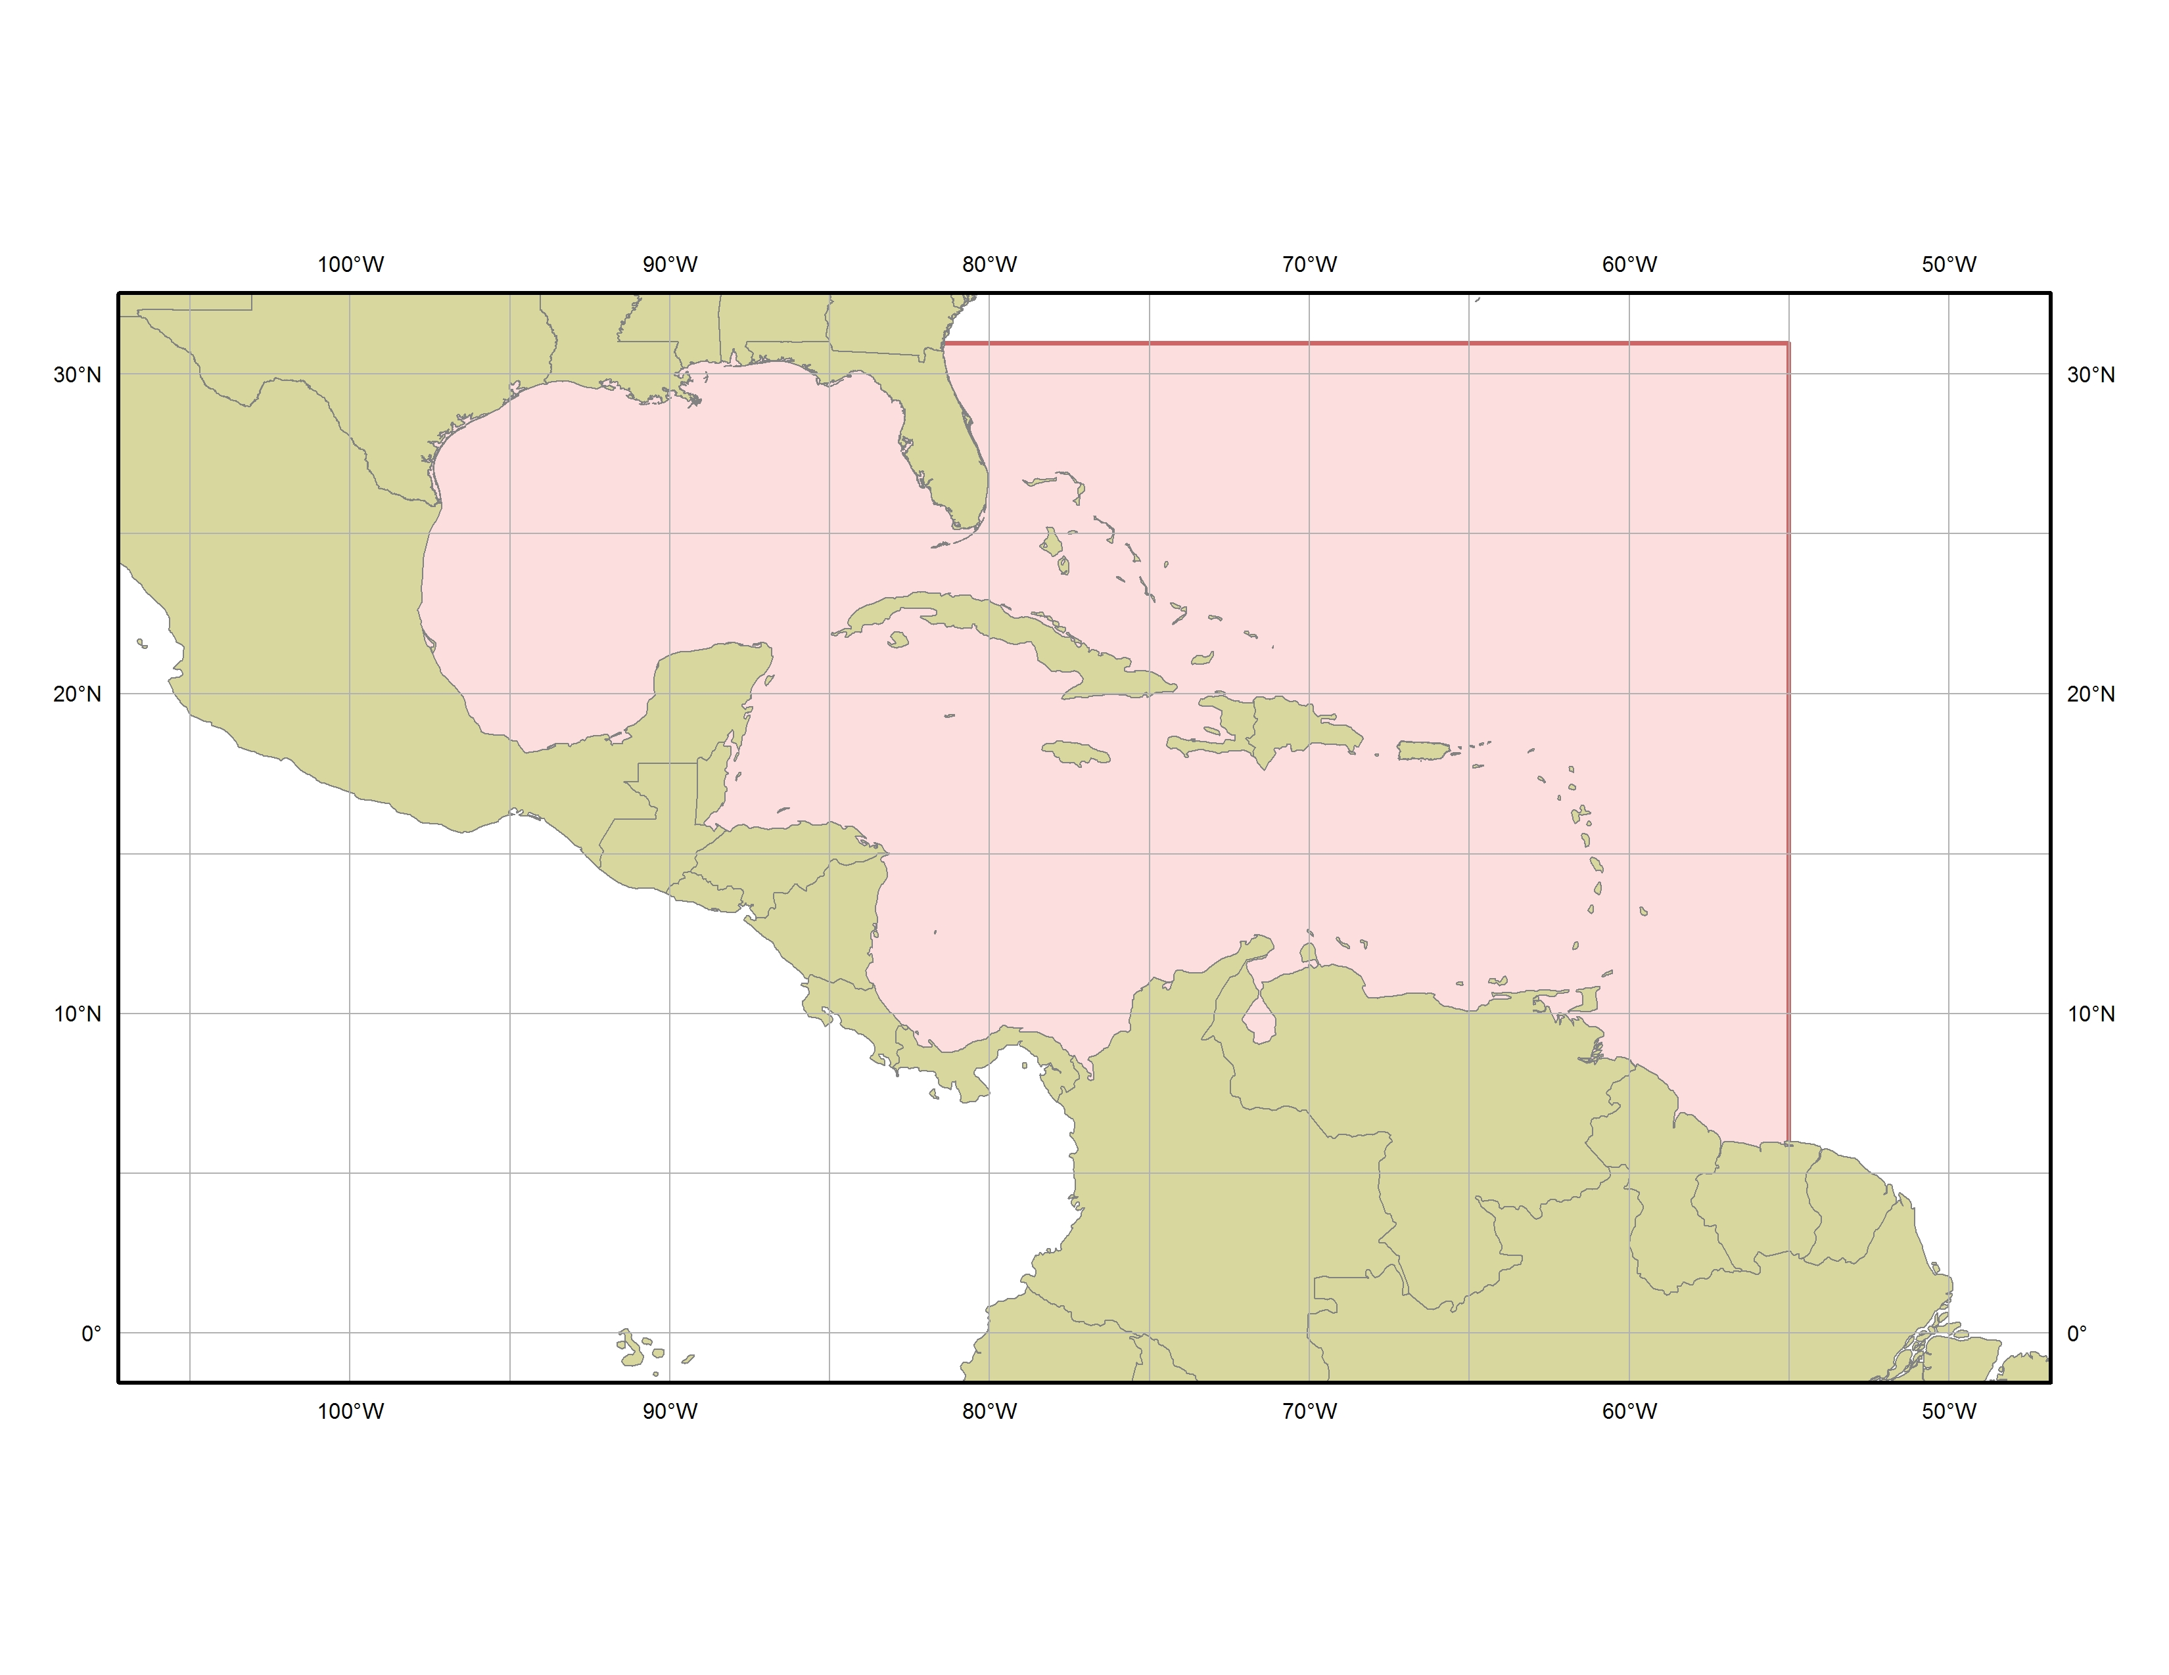   | MARINE WEATHER DISCUSSION | 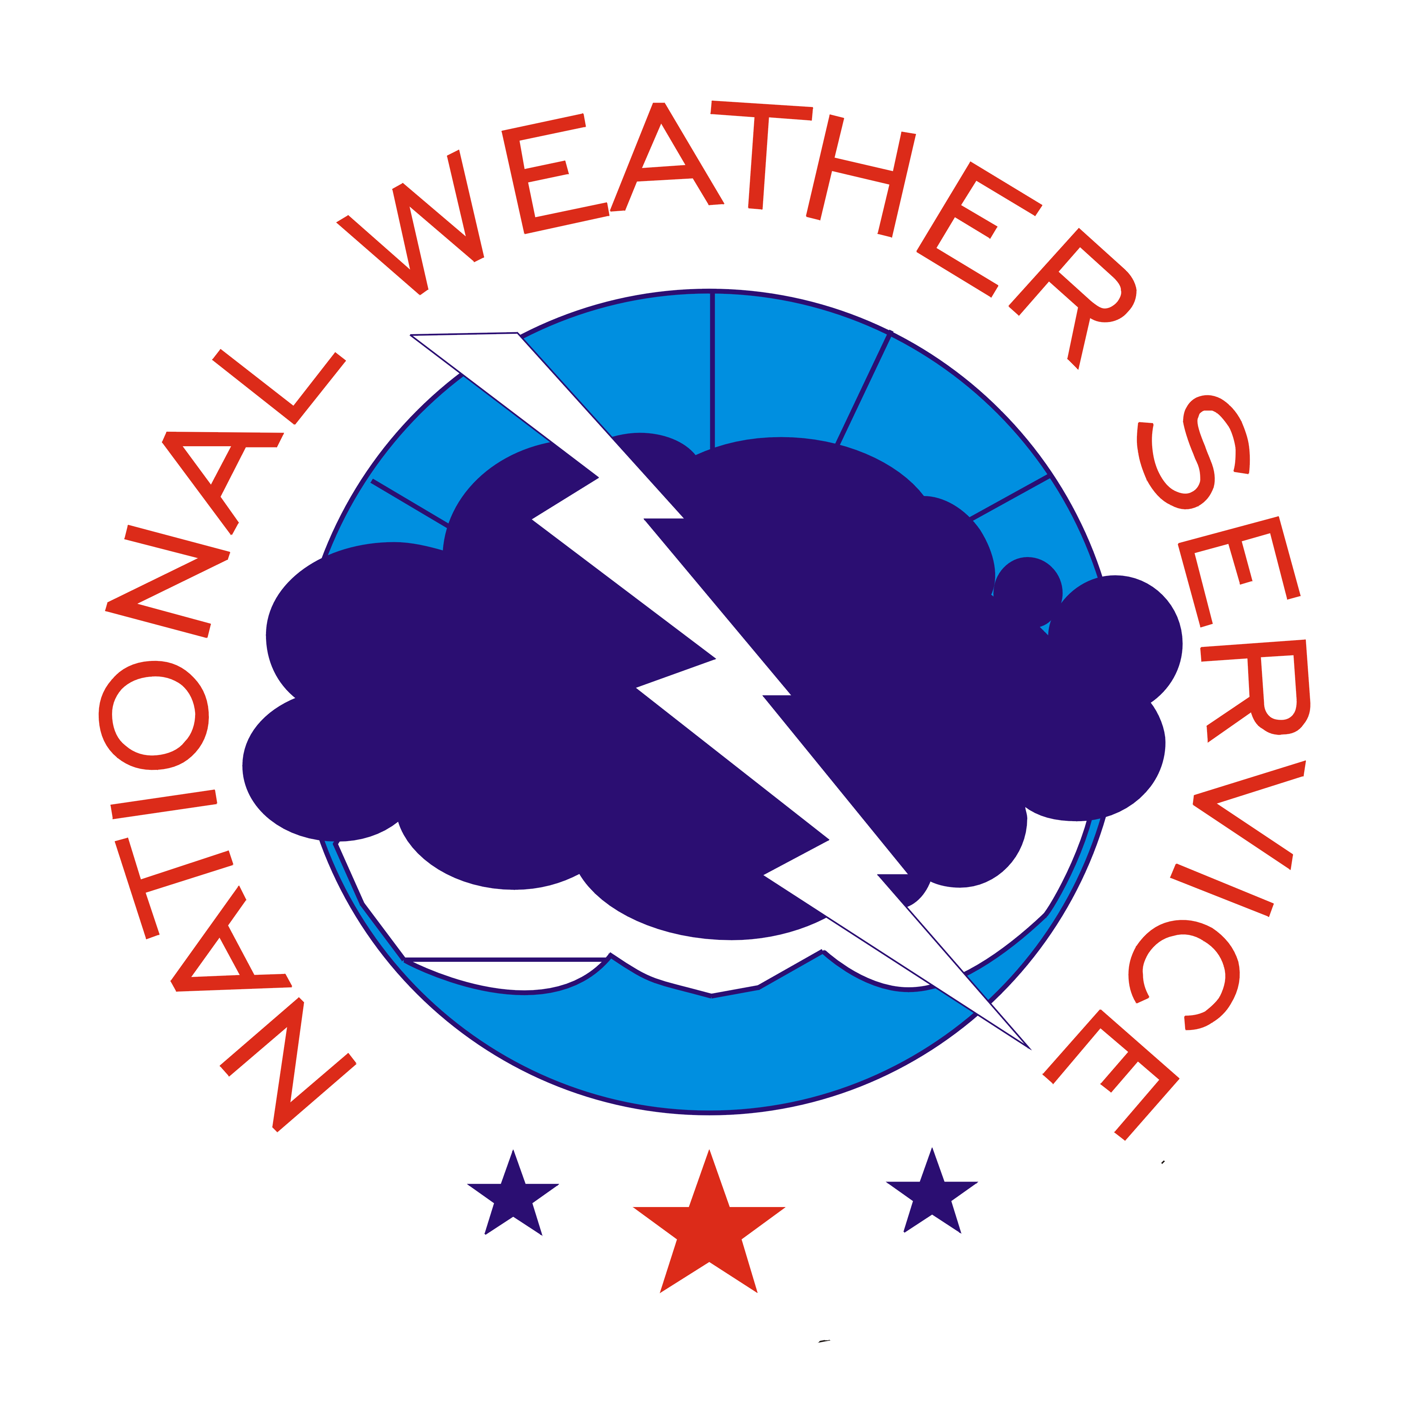

- Purpose
The Marine Weather Discussion is a semi-technical product, analogous to the Area Forecast Discussion (AFD) issued by the local National Weather Service Forecast Offices, primarily used as a means to explain the scientific rationale behind the Offshore Waters Forecast and to summarize the warnings in effect. The Marine Weather Discussion is used to convey forecast and warning information to federal agencies, weather-sensitive officials, and the media. Part of this goal is to enhance coordination with the coastal Weather Forecast Offices.

- Content
The Marine Weather Discussion describes synoptic and mesoscale features expected to affect areas in and adjacent to the offshore waters of the Gulf of Mexico, Caribbean Sea, and Southwest and Tropical North Atlantic Ocean. The narrative describes weather, wind speed, and seas with primary focus on the next 48 hours. The product emphasizes timing and issuance of warnings, includes future trends of wind and sea conditions, discusses the effects of currents such as the Gulf Stream on winds and seas, and addresses how the latest computer model guidance is handling features of significance to the mariner.

- Coverage
The National Hurricane Center issues one Marine Weather Discussion to convey forecast reasoning over both its offshore forecast areas. This area includes the Gulf of Mexico, the Caribbean Sea, the Tropical North Atlantic, and the Southwest North Atlantic Ocean south of 31°N west of 55°W. The area between 55°W and 65°W is not specifically covered by the Offshore Waters Forecast products, but conditions in this area are discussed since they often affect the offshore waters in the future.

  - Issuance / Transmission

The Marine Weather Discussion is transmitted under World Meteorological Organization (WMO) and NOAA Weather Wire Services (NWWS) headers as shown below:

 | WMO | NWWS
Marine Weather Discussion | AGXX40 KNHC | MIAMIMATS

In general, the Marine Weather Discussion is issued twice a day (with updates as needed) shortly before the issuance of the scheduled Offshore Waters Forecast products. Forecasters will issue a brief discussion to provide information of an impending offshore forecast update. The scheduled transmission times are shown below:

 | Issuance Time
MIAMIMATS | by 230 AM EST  (330 AM EDT) | by 230 PM EST  (330 PM EDT)

