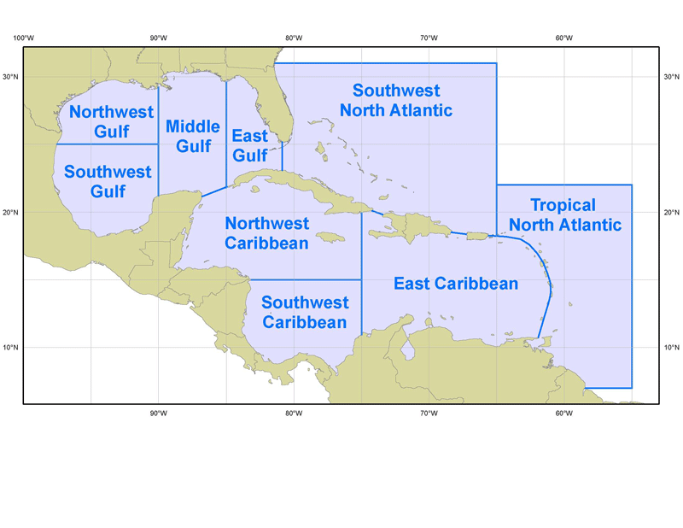  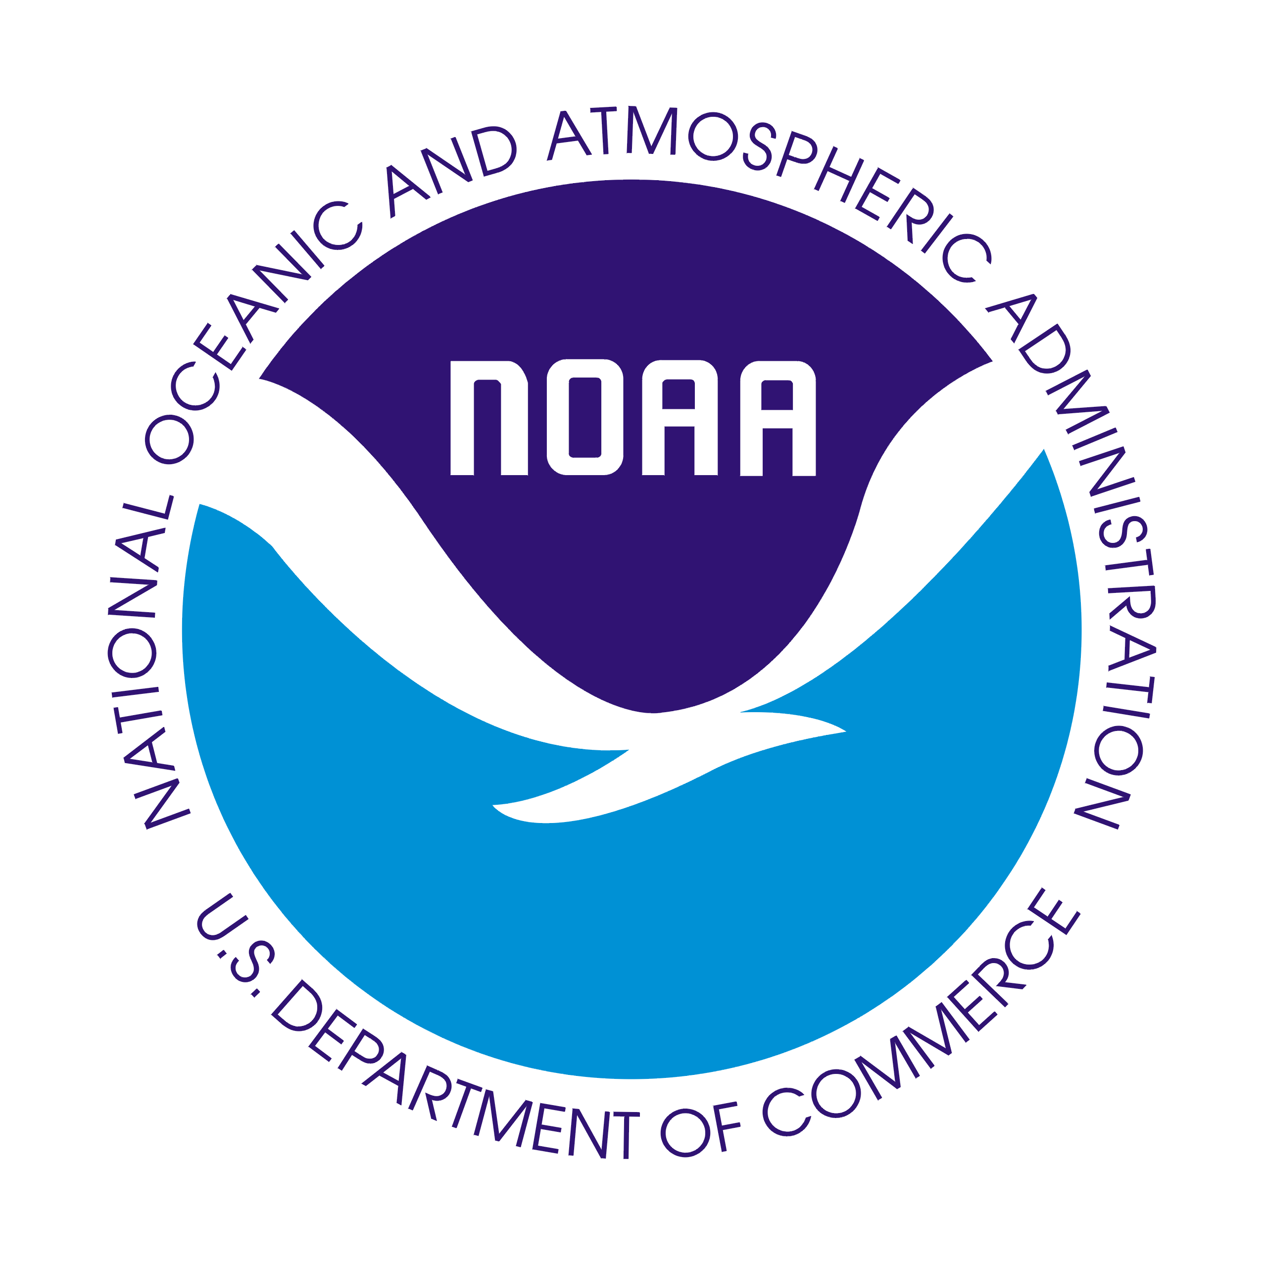 | OFFSHORE WATERS FORECAST | 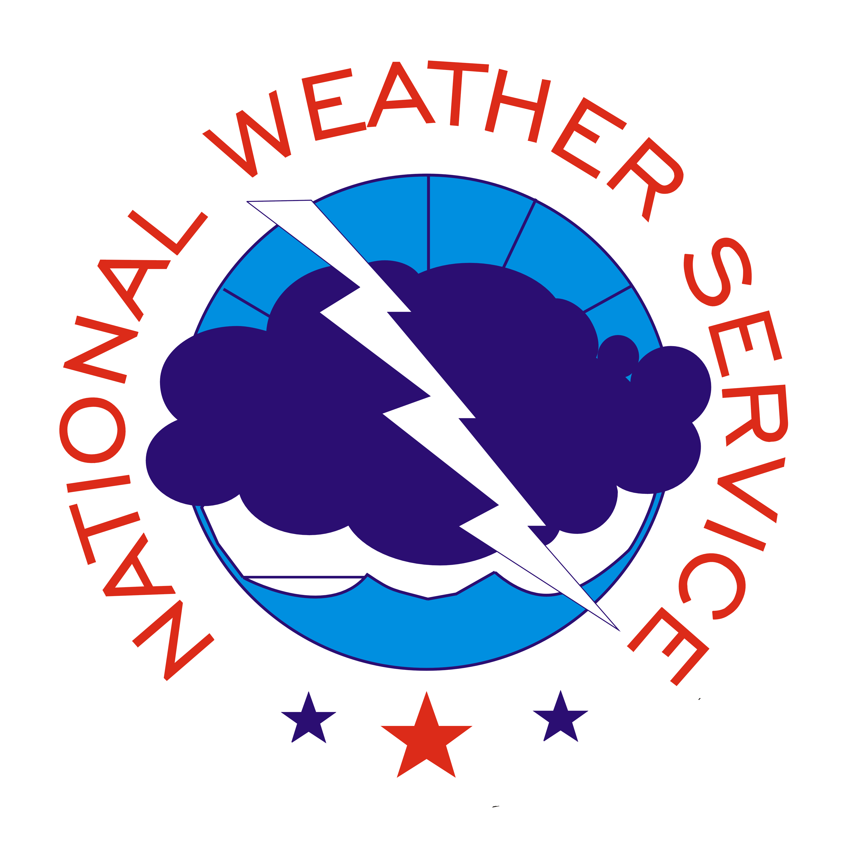

- Purpose
The Offshore Waters Forecast provides forecast and warning information to mariners who travel the oceanic waters adjacent to the U.S. and its territorial coastal waters. This forecast serves customers who operate from the coastal waters to several hundred nautical miles from shore with 10 different products issued by the National Hurricane Center, the Ocean Prediction Center, the Honolulu Weather Forecast Office, the Anchorage Weather Forecast Office, and the Juneau Weather Forecast Office.

- Content
The Offshore Waters Forecast includes a synopsis which describes significant surface weather features that may cause significant winds and seas over the forecast area during the forecast period. The synopsis identifies major weather systems and the strength, trend, and movement of each. The most detail is focused in the first 48 hours of the forecast. The synopsis also includes tropical cyclone forecast positions out to 120 hours.
The offshore waters product provides a forecast for winds and seas over the affected area for roughly the next 5 days. The forecast also includes significant weather which would pose a hazard to navigation, such as precipitation or restrictions to visibility. Warnings are issued when conditions are expected to meet the specific warning criteria during the first two periods of the forecast. Thereafter, a headline is used which shows that the conditions are expected to occur at some time after the first two periods.
- Coverage
The National Hurricane Center issues two separate Offshore Waters Forecasts, as shown below:

Gulf of Mexico offshore waters:
- Northwest Gulf (north of 25°N west of 90°W)
- Southwest Gulf (south of 25°N west of 90°W)
- Middle Gulf (between 85°W and 90°W)
- Eastern Gulf (between 81°W and 85°W)

Southwest and Tropical North Atlantic and Caribbean offshore waters:
- Northwest Caribbean (north of 15°N west of 75°W)
- Southwest Caribbean (south of 15°N west of 75°W)
- Eastern Caribbean (east of 75°W to Leeward and Windward Islands)
- Tropical North Atlantic (from 7°N to 22°N between 55°W and 65°W)
- Southwest North Atlantic (south of 31°N west of 65°W including the Bahamas)

  - Issuance / Transmission
Offshore waters products are transmitted under World Meteorological Organization (WMO) and NOAA Weather Wire Services (NWWS) headers as shown in the following table:

 | WMO | NWWS
Southwest and Tropical  North Atlantic and Caribbean | FZNT23 KNHC | MIAOFFNT3
Gulf of Mexico | FZNT24 KNHC | MIAOFFNT4

Offshore waters products are issued on a regular six hourly schedule as shown below:

 | Issuance Time
MIAOFFNT3 | 430 AM EST  (530 AM EDT) | 1030 AM EST  (1130 AM EDT) | 430 PM EST  (530 PM EDT) | 1030 PM EST  (1130 PM EDT)
MIAOFFNT4 | 330 AM CST  (430 AM CDT) | 930 AM CST  (1030 AM CDT) | 330 PM CST  (430 PM CDT) | 930 PM CST  (1030 PM CDT)

