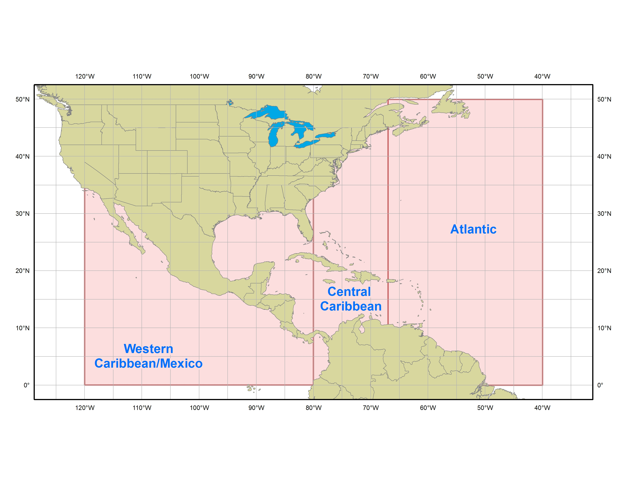   | SATELLITE RAINFALL ESTIMATES | 

- Purpose
Satellite rainfall estimates are provided for tropical cyclones or other significant convective systems (mainly in the tropics) when these systems threaten land. The product is issued when convection systems are affecting the WMO RA-IV area. The product is also issued when system affect the west coast of Mexico. These estimates are based on geostationary infrared satellite imagery using a method called the Woodley-Griffith Technique.

- Content
The satellite rainfall estimate product provides an estimate of the maximum rainfall based on the last four geostationary satellite images six hours apart (24 hours), as well as the estimated maximum rainfall based on the latest geostationary satellite image. The product also provides a rainfall distribution within 4° (240 nautical miles) to the left and right of the observed system motion in 1° (60 nautical miles) increments.

- Coverage
One of three satellite rainfall estimate products is issued for each convective system affecting or expected to affect land based on the system’s initial location:

- Eastern Caribbean (areas between 40°W and 67°W)
- Central Caribbean (areas between 67°W and 80°W)
- Western Caribbean / Mexico (areas between 80°W and 120°W)

  - Issuance / Transmission
The Satellite Tropical Disturbance Rainfall Estimate product is transmitted under World Meteorological Organization (WMO) and NOAA Weather Wire Services (NWWS) headers as shown below:

 | WMO | NWWS
Eastern Caribbean | TCCA21 KNHC | MIASTDECA
Central Caribbean | TCCA22 KNHC | MIASTDCCA
Western Caribbean / Mexico | TCCA23 KNHC | MIASTDWCA

The product is issued four times a day as needed near the synoptic times of 0000, 0600, 1200, and 1800 UTC. The exact issuance time is based on the time of the last satellite image used.

