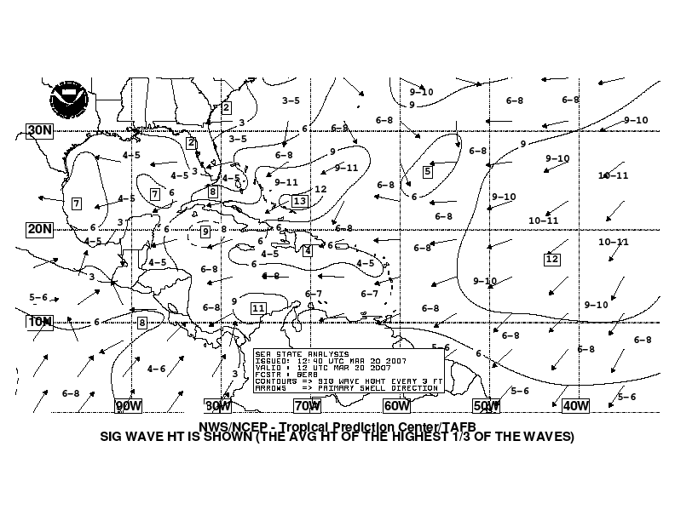 | 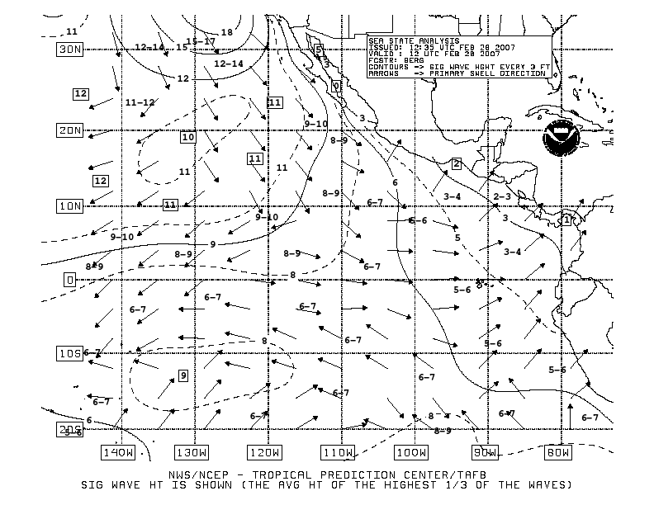SEA STATE ANALYSIS | 

- Purpose
The Sea State Analysis is created every 12 hours, at 0000 and 1200 UTC, to depict the current significant wave height and primary swell direction field over the tropical and subtropical Atlantic and East Pacific waters.

- Content
The significant wave height is contoured at intervals of three feet, with additional contours added if necessary in areas of little spatial variation. The significant wave height is defined as the average height of the highest 1/3 of the waves (individual waves may be more than twice the significant wave height). Maximum and minimum significant wave height values are indicated as necessary. Arrows are also depicted showing the primary swell direction at specific points.

- Coverage
The National Hurricane Center produces two separate sea state analyses twice a day:

- Atlantic (from the equator to 31°N between 35°W and 100°W, including the Pacific east of 100°W)
- East Pacific (from 20°S to 30°N east of 145°W)

  - Issuance / Transmission
The Sea State Analysis is transmitted by radiofax via New Orleans, Pt. Reyes, and Honolulu according to the following table:

 | New Orleans, LA |  | Pt. Reyes, CA |  | Honolulu, HI
Valid Time (UTC) | Transmission Time (UTC) | Filename | Transmission Time (UTC) | Filename | Transmission Time (UTC) | Filename
0000 | 0215 | PJEA88.TIF | 0205 | PKFA88.TIF | 0240 | PKFA88.TIF
1200 | 1415 | PJEA90.TIF | 1425 | PKFA89.TIF | 1440 | PKFA89.TIF
latest |  | PJEA11.TIF |  | PKFA10.TIF |  | PKFA10.TIF

