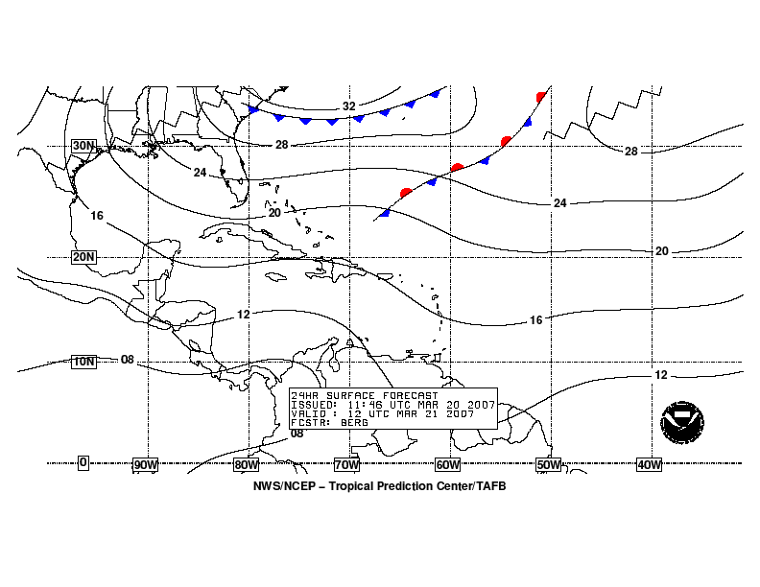 | SURFACE FORECASTS | 
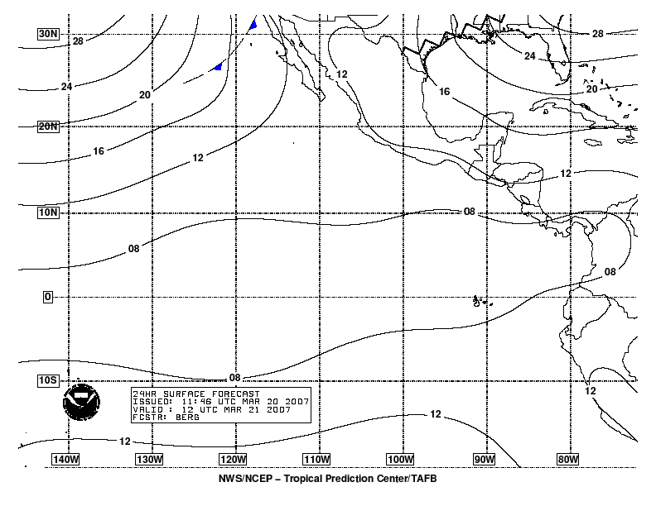

- Purpose
Surface forecasts are produced to depict the 24-, 48-, and 72-hour forecasts of pressure and surface features over the tropical and subtropical Atlantic and East Pacific waters.

- Content
The surface forecasts include the forecast pressure field depicted by isobars contoured every four millibars (mb). Intermediate two millibar isobars are sometimes included in areas where the pressure gradient is relatively light. Relevant surface features are also shown, including areas of high and low pressure, frontal systems (cold, warm, stationary, and occluded), troughs, ridges, drylines, tropical waves, and tropical cyclones. The 72-hour forecast chart also includes a depiction of the 96-hour forecast positions of highs, lows, and tropical cyclones.

- Coverage
The National Hurricane Center produces surface forecasts covering the following areas:

- Atlantic (from the equator to 31°N between 35°W and 100°W, including the Pacific east of 100°W)
- East Pacific (from 20°S to 30°N east of 145°W)

- Issuance / Transmission
The surface forecasts are transmitted by radiofax via New Orleans and Honolulu according to the following table:

 |  | New Orleans, LA  (Atlantic) |  | Honolulu, HI  (East Pacific)
Forecast Period | Valid Time (UTC) | Transmission Time (UTC) | Filename | Transmission Time (UTC) | Filename
24-hour | 0000 | 0105 | PYEE79.TIF | 0200 | PYFE79.TIF
 | 1200 | 1305 | PYEE80.TIF | 1400 | PYFE80.TIF
 | latest |  | PYEE10.TIF |  | PYFE10.TIF
48-hour | 0000 | 0115 | PYEI81.TIF | 0210 | PYFI81.TIF
 | 1200 | 1315 | PYEI82.TIF | 1410 | PYFI82.TIF
 | latest |  | PYEI10.TIF |  | PYFI10.TIF
72-hour | 0000 | 0125 | PYEK83.TIF | 0220 | PYFK83.TIF
 | 1200 | 1325 | PYEK84.TIF | 1420 | PYFK84.TIF
 | latest |  | PYEK10.TIF |  | PYFK10.TIF

