 | PEAK WAVE PERIOD AND  DIRECTION FORECASTS | 
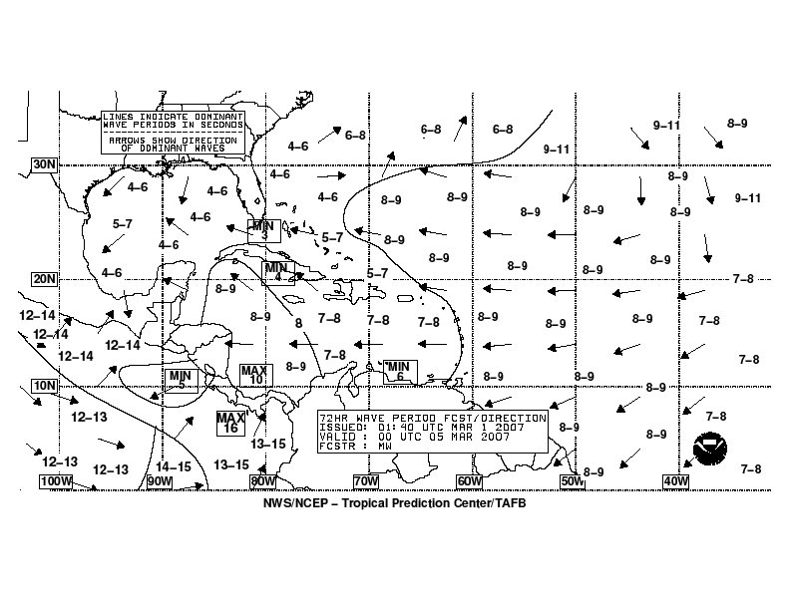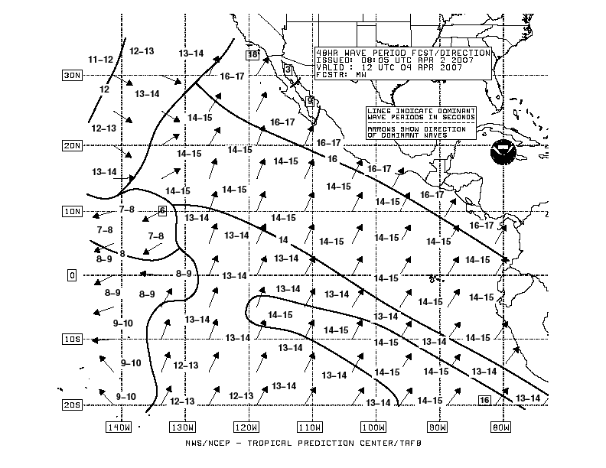

- Purpose
Peak wave period and direction forecast charts are produced to depict the 48- and 72-hour forecasts of how much time exists between the most energetic waves and what direction these waves are coming from over the tropical and subtropical Atlantic and East Pacific waters.

- Content
The peak wave period (in seconds) is defined as the wave period associated with the most energetic waves in the total wave spectrum at a specific point. Wave regimes that are dominated by wind waves tend to have smaller peak wave periods, and regimes that are dominated by swell tend to have larger peak wave periods. It is important to note that these charts only depict the peak wave period and that there still could be other significant waves at a specific point that just happen to have less energy. Peak wave periods are contoured by isolating different swell events with a single line—not contouring at a specific interval as in other forecast graphics. Labels within the contours indicate the peak wave period in that general area. Arrows are also shown depicting the direction that the most energetic waves are traveling.

- Coverage
The National Hurricane Center produces peak wave period and direction forecasts covering the following areas:

- Atlantic (from the equator to 31°N between 35°W and 100°W, including the Pacific east of 100°W)
- East Pacific (from 20°S to 30°N east of 145°W)

- Issuance / Transmission
The peak wave period and direction forecasts are transmitted by radiofax via New Orleans, Pt. Reyes, and Honolulu according to the following table:

 |  | New Orleans, LA (Atlantic) |  | Pt. Reyes, CA  (East Pacific) |  | Honolulu, HI  (East Pacific)
Forecast Period | Valid Time (UTC) | Transmission Time (UTC) | Filename | Transmission Time (UTC) | Filename | Transmission Time (UTC) | Filename
48-hour | 0000 | 0750 | PJEI88.TIF | 2346 | PJFI87.TIF | ----
 | 1200 | 1950 | PJEI89.TIF | 1228 | PJFI88.TIF | 1430 | PJFI88.TIF
 | latest |  | PJEI11.TIF |  | PJFI11.TIF
72-hour | 0000 | 0150 | PKEK88.TIF | 2356 | PJFK93.TIF | 0230 | PJFK93.TIF

