 | WIND / WAVE FORECASTS | 
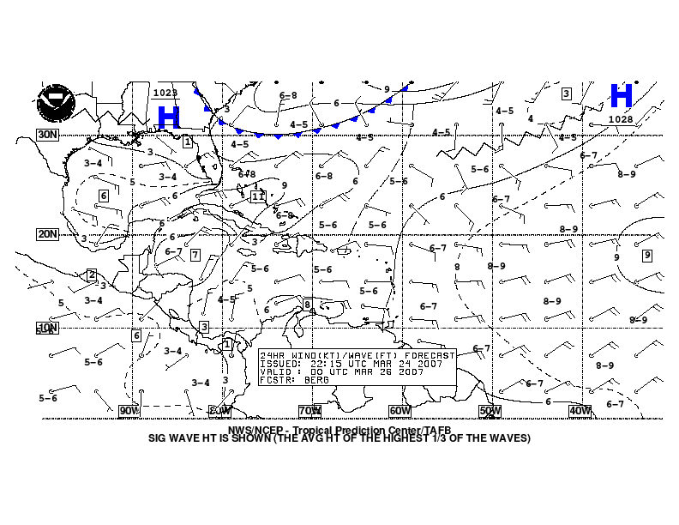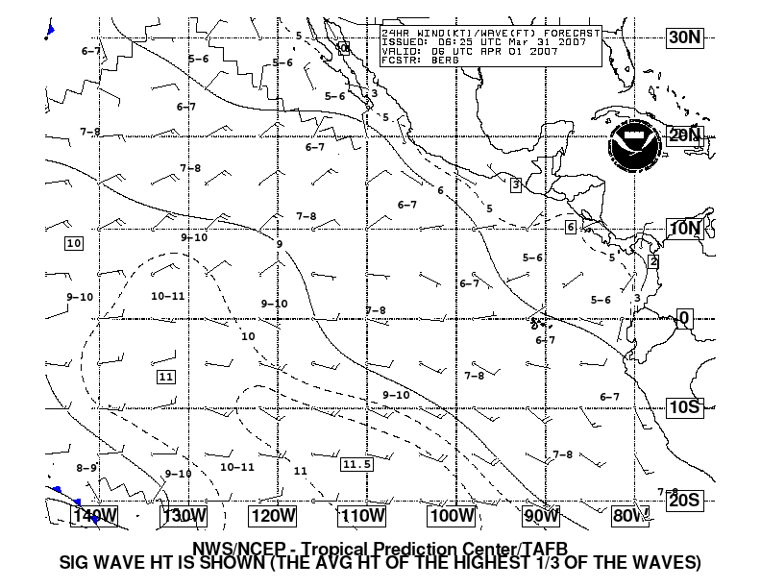

- Purpose
Wind/wave forecasts are produced to depict the 24-, 48-, and 72-hour forecasts of surface features, surface wind speed and direction, and significant wave heights over the tropical and subtropical Atlantic and East Pacific waters.

- Content
The wind/wave forecasts include relevant surface features, including areas of high and low pressure, frontal systems (cold, warm, stationary, and occluded), troughs, ridges, tropical waves, and tropical cyclones. Wind barbs indicate the forecast wind speed and direction at specific points where long barbs indicate 10 knots and short barbs indicate 5 knots. The significant wave height is contoured at intervals of three feet, with additional contours added if necessary in areas of little spatial variation. The significant wave height is defined as the average height of the highest 1/3 of the waves (individual waves may be more than twice the significant wave height). Maximum and minimum significant wave height values are indicated as necessary.

- Coverage
The National Hurricane Center produces wind/wave forecasts covering the following areas:

- Atlantic (from the equator to 31°N between 35°W and 100°W, including the Pacific east of 100°W)
- East Pacific (from 20°S to 30°N east of 145°W)

- Issuance / Transmission
The Wind/wave forecasts are transmitted by radiofax via New Orleans, Pt. Reyes, and Honolulu according to the following table:

 |  | New Orleans, LA  (Atlantic) |  | Pt. Reyes, CA  (East Pacific) |  | Honolulu, HI  (East Pacific)
Forecast Period | Valid Time (UTC) | Transmission Time (UTC) | Filename | Transmission Time (UTC) | Filename | Transmission Time (UTC) | Filename
24-hour | 0000 | 0035 | PWEE89.TIF | 0215 | PWFE01.TIF | 0250 | PWFE01.TIF
 | 0600 | 0635 | PWEE90.TIF | 0959 | PWFE02.TIF | 1008 | PWFE02.TIF
 | 1200 | 1235 | PWEE91.TIF | 1435 | PWFE03.TIF | 1450 | PWFE03.TIF
 | 1800 | 1835 | PWEE92.TIF | 2204 | PWFE04.TIF | 2208 | PWFE04.TIF
 | latest |  | PWEE11.TIF |  | PWFE10.TIF |  | PWFE10.TIF
48-hour | 0000 | 0045 | PWEI88.TIF | 0225 | PWFI88.TIF | 0300 | PWFI88.TIF
 | 1200 | 1245 | PWEI89.TIF | 1208 | PWFI90.TIF | 1500 | PWFI90.TIF
 | latest |  | PWEI11.TIF |  | PWFI10.TIF |  | PWFI10.TIF
72-hour | 0000 | 0055 | PJEK88.TIF | 0235 | PWFK92.TIF | 0310 | PWFK92.TIF
 | 1200 | 1255 | PJEK89.TIF | 1218 | PWFK93.TIF | 1510 | PWFK93.TIF
 | latest |  | PJEK11.TIF |  | PWFK10.TIF |  | PWFK10.TIF

