Tropical Cyclone Report
Tropical Depression Eight
(AL082009)
25-26 September 2009

Todd B. Kimberlain
National Hurricane Center
23 October 2009

Tropical Depression Eight developed from a tropical wave that passed Dakar, Senegal, on 23 September, accompanied by a well-defined mid-level cyclonic circulation, intermittent convection, and 2 to 3 mb 24-hr pressure falls. Ship reports and nearby surface observations indicated that a broad surface low pressure area had formed in association with the wave about midway between the west coast of Africa and the southernmost Cape Verde Islands by 1200 UTC 23 September. Shower and thunderstorm activity remained sporadic in association with the low as it moved west-northwestward at 15 to 20 kt until 24 September. After this time, thunderstorm activity became more persistent and better organized, prompting the initiation of Dvorak satellite classifications at 1800 UTC that day, when the circulation center was 180 n mi southwest of the southern Cape Verde Islands. The system continued to become better organized, with increased banding and a general consolidation of the central convection. It is estimated that a tropical depression formed at 1800 UTC 25 September, when the system was centered about 435 n mi west of the Cape Verde Islands. The “best track” chart of the tropical depression’s path is given in Fig. 1. The best track positions and intensities are listed in Table 1.

Associated convection decreased significantly during the next 6 to 12 hours, as the cyclone took a northwestward course toward a weakness in the subtropical ridge along 35°W. Within an environment of moderate southwesterly shear and marginally high sea surface temperatures of around 26.5°C, the depression did not intensify. UW/CIMSS shear analyses suggest that the shear increased on 26 September and led to a complete removal of the deep convection from the circulation center and an elongation of the circulation along a northeast-southwest axis. The shear persisted, and the depression dissipated into a trough of low pressure by 1800 UTC 26 September. The remnants’ motion then slowed and became westward to west-southwestward in the trade wind flow.

The genesis of Tropical Depression Eight was poorly forecast. None of the global models indicated the potential for this system to develop into a tropical cyclone. The wave that spawned the depression was introduced into the NHC Tropical Weather Outlook 30 h prior to genesis. However, the probability of genesis was in the low category (<30 %) until 6 h before genesis occurred, when it was raised to medium (30 to 50 %).

Table 1. Best track for Tropical Depression Eight, 25 – 26 September 2009.

Date/Time  (UTC) | Latitude  (°N) | Longitude  (°W) | Pressure  (mb) | Wind Speed  (kt) | Stage
25 / 0600 | 14.8 | 29.0 | 1010 | 20 | low
25 / 1200 | 15.4 | 30.1 | 1009 | 25 | "
25 / 1800 | 16.1 | 31.1 | 1008 | 30 | tropical depression
26 / 0000 | 16.7 | 32.2 | 1008 | 30 | "
26 / 0600 | 17.2 | 33.3 | 1008 | 30 | "
26 / 1200 | 17.8 | 34.3 | 1008 | 30 | "
26 / 1800 | 18.6 | 35.2 | 1008 | 25 | "
27 / 0000 |  |  |  |  | dissipated
25 / 1800 | 16.1 | 31.1 | 1008 | 30 | minimum pressure

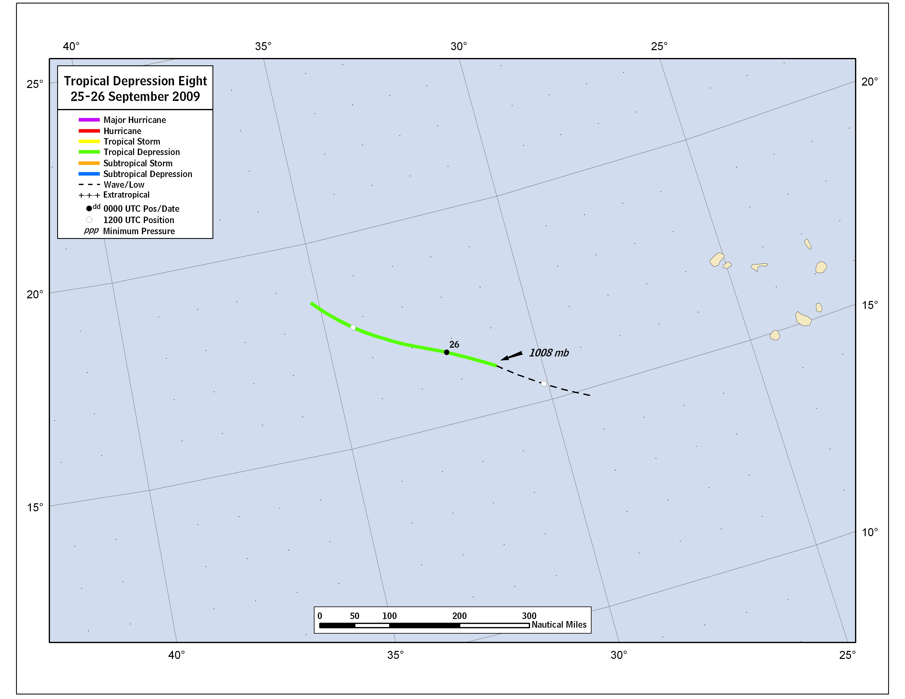
Figure 1. Best track positions for Tropical Depression Eight, 25-26 September 2009.

A digital record of the complete best track can be found on line at ftp://ftp.nhc.noaa.gov/atcf. Data for the current year’s storms are located in the btk directory, while previous years’ data are located in the archive directory.

