Tropical Cyclone Report
Hurricane Helene
(AL092006)
12-24 September 2006

Daniel P. Brown
National Hurricane Center
15 November 2006

Updated 10 January 2007 to adjust storm ID from AL082006 to AL092006

Helene was a long-lived Cape Verde hurricane that remained at sea and attained category 3 intensity on the Saffir-Simpson Hurricane Scale.

- Synoptic History

Helene developed from a vigorous tropical wave and broad area of low pressure that emerged from the coast of Africa on 11 September. Surface observations over western Africa indicate that this wave was accompanied by 24 h pressure falls of 3 to 4 mb. Shower and thunderstorm activity associated with the broad area of low pressure quickly increased and by 1200 UTC 12 September the system showed enough organization to be classified as a tropical depression, the eighth of the 2006 Atlantic hurricane season, while centered approximately 200 n mi south-southeast of the Cape Verde Islands.

The “best track” chart of the tropical cyclone’s path is given in Fig. 1, with the wind and pressure histories shown in Figs. 2 and 3, respectively. The best track positions and intensities are listed in Table 1. As the center of the depression passed about 165 n mi south of the Cape Verde Islands the circulation remained rather large and broad, which along with some easterly shear likely delayed strengthening during the early stage of the system. Convective banding, however, began to increase over the northwestern semicircle of the circulation on 13 September and the depression slowly strengthened, becoming a tropical storm at 0000 UTC 14 September while centered about 425 n mi west-southwest of the Cape Verde Islands.

Moving west-northwestward over the tropical Atlantic Ocean, Helene steadily intensified and became a hurricane at 1200 UTC 16 September, while located about 1000 n mi east of the northern Leeward Islands. The next day Helene turned northwestward and slowed down, due in part to a weakness in the subtropical ridge created by Hurricane Gordon, which was centered a little over 1000 n mi northwest of Helene. Helene continued to strengthen, attaining category 3 status at 0000 UTC 18 September, and six hours later it reached its peak intensity of 105 kt. At this time, Helene and Gordon were at nearly the same longitude, with Gordon centered about 875 n mi north of Helene.

Once Gordon moved east of Helene’s longitude late on 18 September, a narrow mid-to upper-level ridge built to the north of Helene, which caused the hurricane to turn westward on 19 September. During this time microwave satellite data indicated that Helene’s inner eyewall gradually deteriorated (Fig. 4), and Helene weakened to a category 2 hurricane. On 20 September, Helene turned northward ahead of a large deep-layer trough that was exiting the east coast of the United States. Moderate southwesterly shear ahead of this trough induced additional weakening and Helene was reduced to a category one hurricane while passing about 475 n mi east of Bermuda early on 21 September. Thereafter, Helene turned east-northeastward over the open waters of the central Atlantic and retained hurricane strength until becoming extratropical by 1800 UTC 24 September about 275 n mi northwest of the Azores.

On 25 and 26 September, the extratropical cyclone moved northeastward and weakened to a gale center before passing very near the west coast of Ireland on 27 September. A few hours later, the low merged with a larger extratropical low over the north Atlantic around 0000 UTC 28 September, just before reaching northwestern Scotland.

- Meteorological Statistics

Observations in Helene (Figs. 2 and 3) include satellite-based Dvorak technique intensity estimates from the Tropical Analysis and Forecast Branch (TAFB), the Satellite Analysis Branch (SAB) and the U. S. Air Force Weather Agency (AFWA), as well as flight-level and dropwindsonde observations from several NOAA P-3 research missions into Helene. These missions were part of the Saharan Air Layer Experiment (SALEX) and the NOAA Ocean Winds Experiment. Stepped-Frequency Microwave Radiometer (SFMR) data (10 s averages) were also available on four consecutive days. Data from the NOAA aircraft missions were very useful in ascertaining the intensity of Helene during 17-20 September. Microwave satellite imagery from NOAA polar-orbiting satellites, the NASA Tropical Rainfall Measuring Mission (TRMM), the NASA QuikSCAT, and Defense Meteorological Satellite Program (DMSP) satellites were also useful in tracking Helene and assessing its internal structure.

The strongest winds measured by a NOAA reconnaissance aircraft were 111 kt at a flight level of 850 mb in the eastern eyewall at 1831 UTC 17 September. Using a standard eyewall adjustment factor (ratio of surface to flight-level winds of 0.8) yields a surface wind of 89 kt. This wind estimate is in good agreement with both a dropsonde that recorded a 90 kt surface wind and an SFMR maximum wind of 88 kt on this flight. The 105 kt peak intensity of Helene, which occurred about 12 h later at 0600 UTC 18 September, is based on a blend of subjective Dvorak intensity estimates.

Since the NOAA research mission on 18 September was flown at a flight level of 500 mb, obtaining surface winds from this higher-than-normal flight level is problematic, as it is not possible to confidently adjust winds from this altitude to the surface. The SFMR instrument on this flight recorded a peak surface wind of 86 kt and a minimum pressure of 963 mb was reported from the aircraft center fix. Since this flight only made three passes through the center, it may not have adequately sampled the hurricane’s strongest winds. Therefore, the 95 kt maximum wind speed estimate at 1800 UTC 18 September is from a blend of satellite estimates and the aircraft data.

On 19 September, the NOAA aircraft observed maximum flight-level (between 850 and 700 mb) winds of 98 kt at 1726 UTC, and at nearly the same time the SFMR measured maximum surface winds of 83 kt. The NOAA SALEX flight on 20 September provided two center “fixes”, but it may not have adequately sampled the inner core to determine the maximum winds.

QuikSCAT data on 22-23 September support the analysis of Helene as a hurricane until its extratropical transition on 24 September. A QuikSCAT overpass at 0916 UTC 23 September indicated a large area of hurricane-force winds over the southwestern semicircle of the circulation with maximum winds around 80 kt. Since there was no deep convection over this portion of the circulation, these winds did not suffer from rain contamination and are likely representative of the maximum winds at that time.

Ship and buoy reports of winds of tropical storm force associated with Helene are given in Table 2. A few hours before Helene became extratropical it passed within about 20 n mi of drifting buoy 44613 (40.3°N 39.6°W), which reported a minimum pressure of 971.8 mb at 0900 UTC 24 September. Later that day, drifting buoy 44774 (43.5°N 35.8°W) reported a minimum pressure of 967.0 mb at 2300 UTC as the center of extratropical Helene passed nearly directly over that buoy.

After losing tropical characteristics, the system produced gale-force wind gusts across much of Ireland and northwestern Scotland on 27-28 September. The highest reported wind gust in Ireland was 49 kt at the Valentia Observatory, located on the extreme southwestern coast. A wind gust to 64 kt was reported on South Uist Island in the Outer Hebrides of western Scotland.

- Casualty and Damage Statistics

There were no reports of damage or casualties associated with Helene.

- Forecast and Warning Critique

The genesis of Helene was fairly well anticipated. Mention of the tropical wave from which Helene developed was introduced into the Atlantic Tropical Weather Outlook as it emerged from the coast of Africa about 24 h prior to tropical cyclone formation. Customarily, NHC waits until a tropical wave has fully emerged from the coast of Africa before mentioning the possibility of development. The outlooks prior to the development of Helene discussed the potential for genesis, but they did not specifically mention tropical depression formation until a few hours prior to formation. It should be noted that many of the global forecast models accurately predicted the genesis of Helene.

A verification of official and guidance model track forecasts is given in Table 3. Average official track errors for Helene were 27, 42, 61, 86, 124, 161, and 192 n mi for the 12, 24, 36, 48, 72, 96, and 120 h forecasts, respectively. The number of forecasts ranged from 47 at 12 h to 29 at 120 h. These errors are considerably lower than the average long-term official track errors for the 5-year period 2001-2005 (Table 3). The track errors were exceptionally small as forecasts accurately predicted most of Helene’s path over the deep tropical Atlantic. Dynamical track models, however, did not correctly forecast the reduction in Helene’s forward speed and its turn to the northwest on 17 and 18 September. It appears that the global models did not accurately forecast weakening of the subtropical ridge that was located between Hurricanes Gordon and Helene. During this time the global models also did not properly predict the recurvature of Helene, and the official 4 and 5-day track forecasts had track errors that were much larger than the 5-year mean. The track models had a westward or left bias during this period. Helene’s recurvature along 57°W longitude was not captured well by any of the global models at the extended forecast ranges. The GFS and UKMET models indicated that Helene would continue westward to west-northwestward for a longer period of time, suggesting that the hurricane could become a possible threat to Bermuda. Meanwhile, the GFDL model was more accurate in forecasting Helene to turn northward between 57°W and 60°W longitude, and the official track forecast leaned closer to this solution. Overall, the official forecasts had smaller errors at 120 h than all of the available guidance, and at 96 h only the Florida State Superensemble (FSSE) and the CONU and GUNA consensus models beat the NHC track forecasts.

Average official intensity errors were 7, 10, 12, 12, 11, 11, and 10 kt for the 12, 24, 36, 48, 72, 96, and 120 h forecasts, respectively (Table 4). These forecasts are comparable to the average long-term official intensity errors (Table 4) through 48 hours, but they are much lower than the average long-term errors at 72, 96, and 120 h. During the depression stage, the official forecasts predicted the rate of Helene’s strengthening fairly accurately. Intensity forecasts on 17 and 18 September, when Helene was near peak intensity, predicted additional strengthening to a category 4 hurricane, which did not materialize.

Table 1. Best track for Hurricane Helene, 12-24 September 2006.

Date/Time  (UTC) | Latitude  (°N) | Longitude  (°W) | Pressure  (mb) | Wind Speed  (kt) | Stage
12 / 1200 | 11.9 | 22.0 | 1007 | 25 | tropical depression
12 / 1800 | 11.9 | 23.2 | 1007 | 30 | "
13 / 0000 | 11.9 | 24.6 | 1007 | 30 | "
13 / 0600 | 12.0 | 26.1 | 1007 | 30 | "
13 / 1200 | 12.2 | 28.0 | 1007 | 30 | "
13 / 1800 | 12.5 | 30.0 | 1006 | 30 | "
14 / 0000 | 12.9 | 31.9 | 1005 | 35 | tropical storm
14 / 0600 | 13.2 | 33.8 | 1005 | 35 | "
14 / 1200 | 13.6 | 35.6 | 1003 | 40 | "
14 / 1800 | 14.0 | 37.0 | 1003 | 40 | "
15 / 0000 | 14.4 | 38.3 | 1002 | 40 | "
15 / 0600 | 14.8 | 39.6 | 1000 | 45 | "
15 / 1200 | 15.5 | 40.8 | 997 | 50 | "
15 / 1800 | 16.2 | 42.1 | 995 | 55 | "
16 / 0000 | 17.0 | 43.3 | 992 | 60 | "
16 / 0600 | 17.7 | 44.3 | 990 | 60 | "
16 / 1200 | 18.4 | 45.3 | 987 | 65 | hurricane
16 / 1800 | 18.9 | 46.2 | 986 | 65 | "
17 / 0000 | 19.4 | 47.1 | 983 | 70 | "
17 / 0600 | 19.9 | 47.9 | 979 | 75 | "
17 / 1200 | 20.3 | 48.4 | 976 | 80 | "
17 / 1800 | 20.8 | 48.8 | 970 | 90 | "
18 / 0000 | 21.4 | 49.1 | 962 | 100 | "
18 / 0600 | 22.0 | 49.4 | 955 | 105 | "
18 / 1200 | 22.7 | 49.7 | 958 | 105 | "
18 / 1800 | 23.6 | 50.4 | 962 | 95 | "
19 / 0000 | 24.0 | 51.0 | 962 | 95 | "
19 / 0600 | 24.3 | 51.7 | 960 | 95 | "
19 / 1200 | 24.4 | 52.5 | 958 | 95 | "
19 / 1800 | 24.4 | 53.5 | 956 | 90 | "
20 / 0000 | 24.5 | 54.4 | 958 | 90 | "
20 / 0600 | 24.9 | 55.2 | 958 | 90 | "
20 / 1200 | 25.4 | 56.0 | 959 | 90 | "
20 / 1800 | 25.9 | 56.7 | 960 | 80 | "
21 / 0000 | 26.8 | 57.0 | 962 | 80 | "
21 / 0600 | 27.8 | 57.0 | 964 | 75 | "
21 / 1200 | 29.0 | 57.0 | 968 | 75 | "
21 / 1800 | 30.2 | 57.0 | 970 | 75 | "
22 / 0000 | 31.4 | 56.6 | 970 | 75 | "
22 / 0600 | 32.5 | 55.9 | 970 | 70 | "
22 / 1200 | 33.6 | 55.1 | 970 | 70 | "
22 / 1800 | 34.9 | 53.7 | 968 | 70 | "
23 / 0000 | 35.7 | 51.7 | 964 | 75 | "
23 / 0600 | 36.4 | 49.6 | 962 | 80 | "
23 / 1200 | 37.1 | 47.5 | 962 | 80 | "
23 / 1800 | 37.7 | 45.4 | 963 | 75 | "
24 / 0000 | 38.6 | 43.2 | 964 | 70 | "
24 / 0600 | 39.5 | 40.9 | 964 | 65 | "
24 / 1200 | 40.6 | 38.2 | 964 | 65 | "
24 / 1800 | 42.0 | 35.9 | 964 | 65 | extratropical
25 / 0000 | 43.2 | 34.7 | 964 | 65 | "
25 / 0600 | 44.1 | 33.3 | 966 | 65 | "
25 / 1200 | 44.7 | 31.7 | 968 | 60 | "
25 / 1800 | 44.9 | 29.8 | 972 | 55 | "
26 / 0000 | 45.0 | 27.6 | 977 | 50 | "
26 / 0600 | 45.5 | 25.2 | 980 | 50 | "
26 / 1200 | 46.0 | 22.7 | 984 | 50 | "
26 / 1800 | 47.2 | 20.1 | 986 | 45 | "
27 / 0000 | 49.0 | 17.0 | 988 | 45 | "
27 / 0600 | 51.3 | 13.3 | 988 | 45 | "
27 / 1200 | 53.9 | 10.1 | 988 | 40 | "
27 / 1800 | 56.3 | 7.6 | 988 | 40 | "
28 / 0000 |  |  |  |  | merged with extratropical low
18 / 0600 | 22.0 | 49.4 | 955 | 105 | minimum pressure

Table 2. Selected ship and buoy observations with winds of at least 34 kt for Hurricane Helene, 12-24 September 2006.

Date/Time (UTC) | Ship call sign | Latitude  (°N) | Longitude  (°W) | Wind  dir/speed (kt) | Pressure  (mb)
14/1700 | buoy 13008 | 15.0 | 38.0 | 34
19 / 0600 | S6TV | 23.5 | 45.2 | 100 / 39 | 1012.0
22 / 1000 | buoy 41643 | 34.5 | 55.9 | 100 / 47 | 995.4
22 / 1300 | buoy 41643 | 34.5 | 55.9 | 030 / 41 | 991.3
23 / 0600 | DEDM | 33.5 | 47.4 | 230 / 49 | 1007.0
23 / 1200 | PBHU | 33.1 | 44.8 | 180 / 37 | 1010.9

Table 3 . Preliminary track forecast evaluation (heterogeneous sample) for Hurricane Helene, 12-24 September 2006. Forecast errors (n mi) are followed by the number of forecasts in parentheses. Errors smaller than the NHC official forecast are shown in bold-face type. Verification includes the depression stage, but does not include the extratropical stage.

Forecast Technique | Forecast Period (h)
Forecast Technique | 12 | 24 | 36 | 48 | 72 | 96 | 120
CLP5 | 41 (47) | 85 (45) | 131 (43) | 177 (41) | 261 (37) | 299 (33) | 219 (29)
GFNI | 34 (42) | 58 (40) | 83 (38) | 110 (36) | 180 (32) | 223 (28) | 307 (26)
GFDI | 29 (46) | 49 (44) | 68 (42) | 95 (40) | 144 (36) | 171 (32) | 265 (28)
GFSI | 24 (46) | 41 (44) | 62 (42) | 91 (40) | 162 (36) | 223 (32) | 304 (28)
AEMI | 24 (46) | 39 (44) | 57 (42) | 82 (40) | 133 (36) | 165 (32) | 242 (28)
NGPI | 29 (43) | 45 (41) | 61 (39) | 81 (37) | 127 (33) | 199 (29) | 322 (26)
UKMI | 34 (46) | 55 (44) | 74 (42) | 94 (40) | 159 (36) | 190 (32) | 250 (28)
BAMD | 35 (47) | 61 (45) | 87 (43) | 118 (41) | 203 (37) | 279 (33) | 410 (29)
BAMM | 35 (47) | 65 (45) | 98 (43) | 124 (41) | 170 (37) | 230 (33) | 319 (29)
BAMS | 44 (47) | 79 (45) | 113 (43) | 140 (41) | 188 (37) | 242 (33) | 327 (29)
CONU | 25 (46) | 38 (44) | 53 (42) | 73 (40) | 123 (36) | 157 (32) | 199 (28)
GUNA | 25 (43) | 37 (41) | 50 (39) | 70 (37) | 120 (33) | 144 (29) | 201 (26)
FSSE | 24 (41) | 38 (39) | 59 (37) | 83 (35) | 132 (31) | 153 (27) | 210 (23)
OFCL | 27 (47) | 42 (45) | 61 (43) | 86 (41) | 124 (37) | 161 (33) | 192 (29)
NHC Official  (2001-2005 mean) | 37  (1930) | 65  (1743) | 91  (1569) | 118  (1410) | 171  (1138) | 231  (913) | 303  (742)

Table 4. Preliminary intensity forecast evaluation (heterogeneous sample) for Hurricane Helene, 12-24 September 2006. Forecast errors (kt) are followed by the number of forecasts in parentheses. Errors smaller than the NHC official forecast are shown in bold-face type. Verification includes the depression stage, but does not include the extratropical stage.

Forecast Technique | Forecast Period (h)
Forecast Technique | 12 | 24 | 36 | 48 | 72 | 96 | 120
SHF5 | 7.3 (47) | 9.2 (45) | 10.0 (43) | 10.6 (41) | 10.4 (37) | 11.7 (33) | 13.8 (29)
GFDI | 7.4 (46) | 9.4 (44) | 8.5 (42) | 9.8 (40) | 11.3 (36) | 12.5 (32) | 10.6 (28)
SHIP | 8.0 (47) | 11.5 (45) | 13.8 (43) | 15.1 (41) | 16.5 (37) | 11.9 (33) | 6.4 (29)
DSHP | 8.0 (47) | 11.5 (45) | 13.8 (43) | 15.1 (41) | 16.5 (37) | 11.9 (33) | 6.4 (29)
FSSE | 9.0 (41) | 11.2 (39) | 12.2 (37) | 12.9 (35) | 12.6 (31) | 7.4 (27) | 6.0 (23)
ICON | 7.4 (43) | 9.0 (41) | 9.2 (39) | 9.4 (37) | 10.7 (33) | 9.6 (29) | 6.4 (27)
OFCL | 7.4 (47) | 10.4 (45) | 11.6 (43) | 11.8 (41) | 11.2 (37) | 10.6 (33) | 9.8 (29)
NHC Official  (2001-2005 mean) | 6.3 (1930) | 9.8 (1743) | 12.1 (1569) | 14.3 (1410) | 18.4 (1138) | 19.8 (913) | 21.8 (742)

Figure 1. Best track positions for Hurricane Helene, 12-24 September 2006. Track during the extratropical stage is partially based on analyses from the NOAA Ocean Prediction Center.
Figure 2. Selected wind observations and best track maximum sustained surface wind speed curve for Hurricane Helene, 12-24 September 2006. Aircraft observations have been adjusted for elevation using 90%, 80%, and 80% reduction factors for observations from 700 mb, 850 mb, and 1500 ft, respectively. Dropwindsonde observations include actual 10 m winds (sfc), as well as surface estimates derived from the mean wind over the lowest 150 m of the wind sounding (LLM), and from the sounding boundary layer mean (MBL). Estimates during the extratropical stage are partially based on analyses from the NOAA Ocean Prediction Center.
Figure 3. Selected pressure observations and best track minimum central pressure curve for Hurricane Helene, 12-24 September 2006. Estimates during the extratropical stage are based on analyses from the NOAA Ocean Prediction Center.
A) 1205 UTC 18 September B) 2322 UTC 18 September C) 1152 UTC 19 September
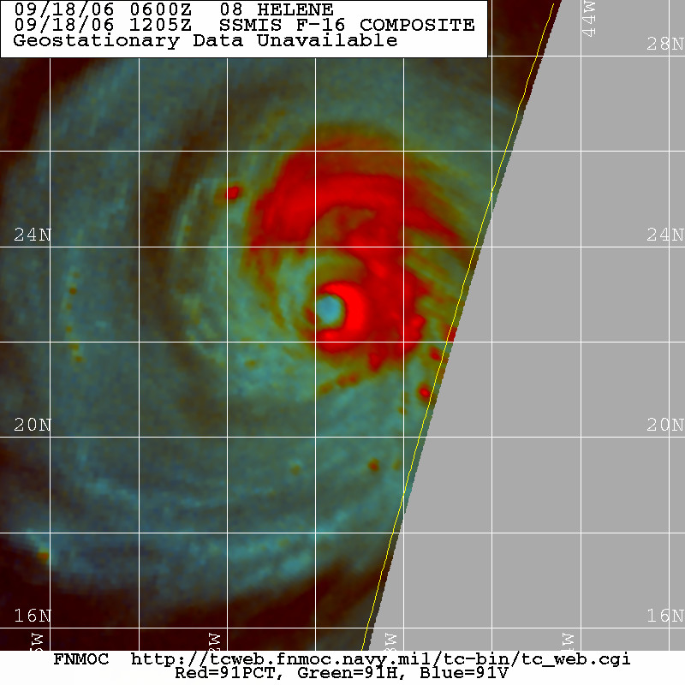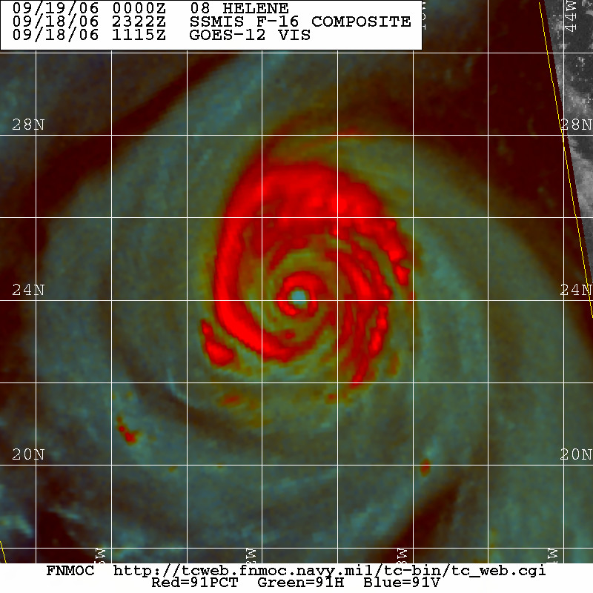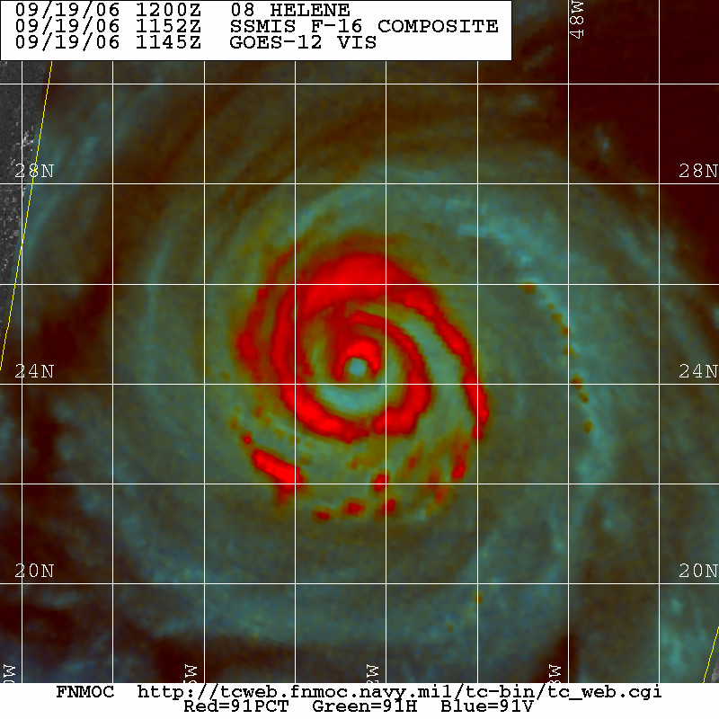
D) 2309 UTC 19 September E) 0532 UTC 20 September F) 1449 UTC 20 September
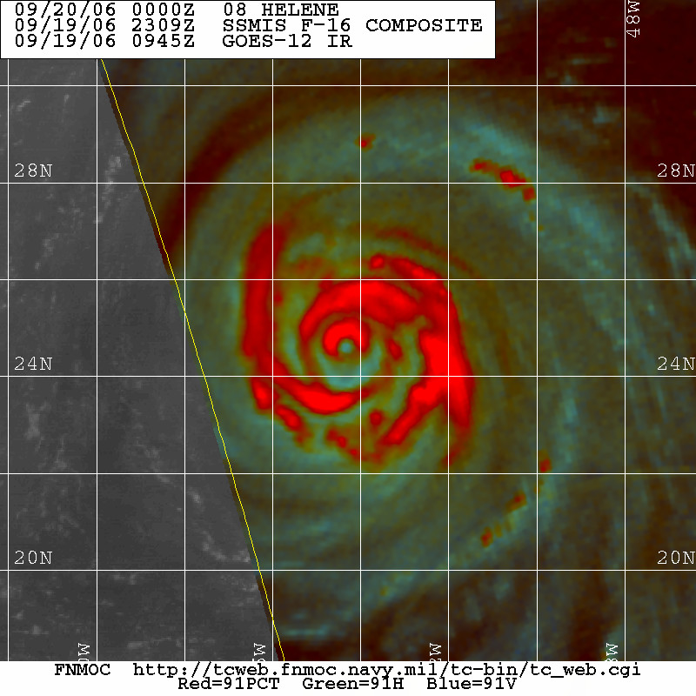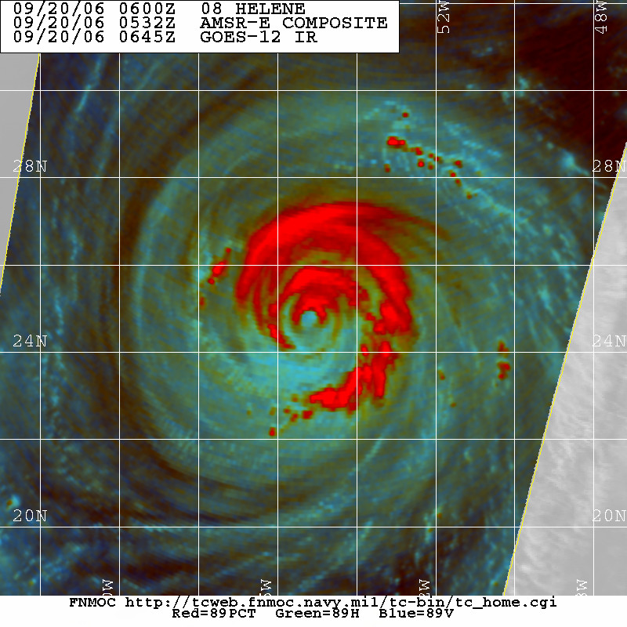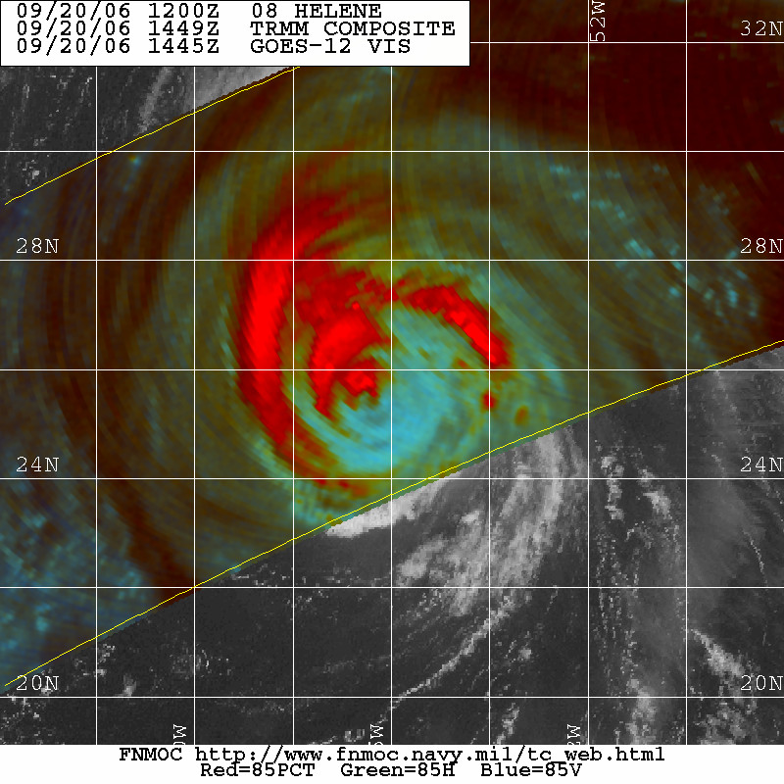

Figure 4. Series f composite 85-91 GHz passive microwave images of Hurricane Helene during 18-20 September 2006. Images courtesy of the Fleet Numerical Meteorology and Oceanography Center (FNMOC).

