Tropical Cyclone Report
Tropical Storm Julio
(EP112008)
23-26 August 2008

Richard J. Pasch
National Hurricane Center
10 February 2009

Julio made landfall in the southern Baja California peninsula as a weak tropical storm.

- Synoptic History

The tropical wave that moved off the west coast of Africa on 6 August and spawned Atlantic Tropical Storm Fay on 15 August near Puerto Rico also appears to have produced Julio. The wave crossed southern Central America and moved over the eastern North Pacific Ocean on 17 August. There was not much organized deep convection associated with the wave as it proceeded westward to the south of Central America and Mexico over the next several days. By 21 August, there was an increase in showers and thunderstorms associated with the system while it was located a couple hundred n mi to the south of Acapulco, Mexico. A broad surface low pressure system soon formed in this region, but development was hindered by strong easterly vertical wind shear. By 1200 UTC 23 August, however, deep convection became persistent enough near the center of the low to warrant its designation as a tropical depression centered about 315 n mi south-southeast of the southern tip of Baja California (Cabo San Lucas). The “best track” chart of the tropical cyclone’s path is given in Fig. 1, with the wind and pressure histories shown in Figs. 2 and 3, respectively. The best track positions and intensities are listed in Table 1.

About six hours after formation, the depression strengthened slightly and became a tropical storm. Julio moved north-northwestward along the periphery of a mid-tropospheric high pressure area over west-central Mexico. Although east-northeasterly shear continued to inhibit intensification, the storm strengthened a little more, and it reached its peak intensity of 45 kt around 1200 to 1800 UTC 24 August, during which time the center passed near and just west of Cabo San Lucas. Julio then made landfall in southern Baja California, about 35 n mi west-southwest of La Paz around 0000 UTC 25 August, with an estimated intensity of 40 kt. The system continued to move north-northwestward along the Baja peninsula that day while slowly weakening. Julio turned northward and its center reached the Gulf of California in the vicinity of Santa Rosalia just before 0000 UTC 26 August, by which time the cyclone had weakened to a tropical depression. Julio slowed and turned eastward over the central Gulf of California while gradually weakening, and degenerated into a remnant low by 1800 UTC 26 August. The low drifted eastward, and it dissipated near Tastiota, on the coast of mainland Mexico, by 1200 UTC 27 August.

- Meteorological Statistics

Observations in Julio (Figs. 2 and 3) include satellite-based Dvorak technique intensity estimates from the Tropical Analysis and Forecast Branch (TAFB) and the Satellite Analysis Branch (SAB) as well as ship reports. Data and imagery from NOAA polar-orbiting satellites, the NASA Tropical Rainfall Measuring Mission (TRMM), the NASA QuikSCAT, and Defense Meteorological Satellite Program (DMSP) satellites, among others, were also useful in tracking Julio.

Ship reports of tropical storm-force winds associated with Julio are given in Table 2. An automated station at Cabo San Lucas, operated by the Meteorological Service of Mexico, reported a 10-min average wind of 38 kt with a gust to 51 kt around 1600 UTC 24 August. This wind sensor is at an elevation of about 735 feet above sea level. Twenty-four hour rainfall totals of 6.54 in and 5.20 in were reported in southern Baja California at Loreto on 24 August and at Mulege on 25 August, respectively.

- Casualty and Damage Statistics

Julio caused one death, a drowning near Mulege in Baja California. Julio produced some flooding over the Baja California peninsula, although damage estimates for Mexico are not available.

- Forecast and Warning Critique

The tropical wave and associated area of disturbed weather that formed into Julio were first mentioned in the Tropical Weather Outlook (TWO) 42 h before the time of the tropical cyclone’s genesis, and the genesis probabilities went from the “low” to the “medium” category 36 h before formation. However the potential for the system to become a tropical depression was not stated in the TWO until 18 h prior to genesis, and the probability was only set to “high” right at the time of genesis.

A verification of official and guidance model track forecasts is given in Table 3. Average official track errors for Julio were 31, 59, 90, 116, and 159 n mi for the 12, 24, 36, 48, and 72 h forecasts, respectively. The number of forecasts ranged from 11 at 12 h to just one at 72 h. These errors are somewhat greater than the average 5-yr official track errors for the 24 through 72 h forecast intervals (Table 4), albeit for a very small sample of forecasts.

A verification of official and guidance model intensity forecasts is given in Table 4. Average official intensity errors were 3, 4, 4, 4, and 10 kt for the 12, 24, 36, 48, and 72 h forecasts, respectively. For comparison, the average 5-yr official intensity errors are 6, 10, 14, 16, and 19 kt, respectively.

Watches and warnings associated with Julio are given in Table 5. A tropical storm warning was issued for a portion of southern Baja California about 21 h prior to landfall in that area. However it is likely that Julio’s radius of maximum winds, and tropical storm-force winds, were onshore in the warning area within 15 h of the issuance of the warning.
Table 1. Best track for Tropical Storm Julio, 23-26 August 2008.

Date/Time  (UTC) | Latitude  (°N) | Longitude  (°W) | Pressure  (mb) | Wind Speed  (kt) | Stage
23 / 1200 | 18.2 | 107.5 | 1007 | 30 | tropical depression
23 / 1800 | 19.1 | 108.1 | 1005 | 35 | tropical storm
24 / 0000 | 20.0 | 108.6 | 1002 | 40 | "
24 / 0600 | 20.9 | 109.2 | 1001 | 40 | "
24 / 1200 | 21.9 | 109.8 | 1000 | 45 | "
24 / 1800 | 22.9 | 110.2 | 998 | 45 | "
25 / 0000 | 23.9 | 110.9 | 999 | 40 | "
25 / 0600 | 25.2 | 111.5 | 1001 | 35 | "
25 / 1200 | 26.3 | 112.0 | 1001 | 35 | "
25 / 1800 | 27.1 | 112.3 | 1001 | 35 | "
26 / 0000 | 27.6 | 112.4 | 1001 | 30 | tropical depression
26 / 0600 | 28.0 | 112.4 | 1003 | 30 | "
26 / 1200 | 28.2 | 112.2 | 1005 | 25 | "
26 / 1800 | 28.3 | 112.1 | 1005 | 25 | low
27 / 0000 | 28.3 | 111.9 | 1005 | 25 | "
27 / 0600 | 28.3 | 111.6 | 1007 | 20 | "
27 / 1200 |  |  |  |  | dissipated
24 / 1800 | 22.9 | 110.2 | 998 | 45 | minimum pressure
25 / 0000 | 23.9 | 110.9 | 999 | 40 | landfall on the west coast of southern Baja California about 35 n mi west-southwest of La Paz

Table 2. Selected ship reports with winds of at least 34 kt for Tropical Storm Julio, 23-26 August 2008.

Date/Time (UTC) | Ship call sign | Latitude  (°N) | Longitude  (°W) | Wind  dir/speed (kt) | Pressure  (mb)
23 / 2000 | DDFD2 | 19.2 | 108.5 | 350 / 40 | 1004.0
24 / 0000 | DHER | 20.7 | 107.9 | 130 / 35 | 1004.5
24 / 0100 | DDFD2 | 19.7 | 110.1 | 330 / 35 | 1006.0

Table 3. Track forecast evaluation (heterogeneous sample) for Tropical Storm Julio, 23-26 August 2008. Forecast errors (n mi) are followed by the number of forecasts in parentheses. Errors smaller than the NHC official forecast are shown in boldface type.

Forecast Technique | Forecast Period (h)
Forecast Technique | 12 | 24 | 36 | 48 | 72 | 96 | 120
CLP5 | 37 (11) | 85 ( 9) | 117 ( 7) | 170 ( 5) | 346 ( 1)
GFNI | 51 ( 8) | 90 ( 6) | 101 ( 4) | 115 ( 2)
GFDI | 36 (11) | 57 ( 9) | 74 ( 7) | 90 ( 5) | 138 ( 1)
HWFI | 34 (11) | 46 ( 9) | 78 ( 7) | 110 ( 5) | 88 ( 1)
GFSI | 35 (10) | 68 ( 8) | 109 ( 6) | 171 ( 4)
AEMI | 43 (11) | 84 ( 8) | 127 ( 6) | 84 ( 2)
NGPI | 63 (10) | 114 ( 7) | 183 ( 5) | 216 ( 2)
UKMI | 38 (10) | 59 ( 8) | 81 ( 6) | 117 ( 4)
EGRI | 33 (10) | 53 ( 8) | 79 ( 6) | 110 ( 4)
EMXI | 25 ( 9) | 57 ( 8) | 102 ( 6) | 156 ( 5)
BAMD | 45 (11) | 97 ( 9) | 155 ( 7) | 223 ( 5) | 378 ( 1)
BAMM | 34 (11) | 76 ( 9) | 142 ( 7) | 227 ( 5) | 357 ( 1)
BAMS | 45 (11) | 101 ( 9) | 160 ( 7) | 235 ( 5) | 326 ( 1)
LBAR | 35 (11) | 71 ( 9) | 102 ( 7) | 153 ( 5) | 261 ( 1)
TVCN | 32 (11) | 57 ( 9) | 86 ( 7) | 111 ( 5) | 96 ( 1)
GUNA | 33 ( 9) | 50 ( 6) | 53 ( 4) | 69 ( 2)
FSSE | 30 ( 9) | 48 ( 7) | 60 ( 4) | 110 ( 1)
OFCL | 31 (11) | 59 ( 9) | 90 ( 7) | 116 ( 5) | 159 ( 1)
NHC Official  (2003-2007 mean) | 31.9 (1282) | 55.1 (1129) | 77.4 (979) | 97.9 (849) | 136.2 (620) | 180.1 (439) | 226.1 (293)

Table 4. Intensity forecast evaluation (heterogeneous sample) for Tropical Storm Julio, 23-26 August 2008. Forecast errors (kt) are followed by the number of forecasts in parentheses. Errors smaller than the NHC official forecast are shown in boldface type.

Forecast Technique | Forecast Period (h)
Forecast Technique | 12 | 24 | 36 | 48 | 72 | 96 | 120
OCD5 | 4.6 (11) | 2.8 ( 9) | 2.7 ( 7) | 3.4 ( 5) | 23.0 ( 1)
GHMI | 6.2 (11) | 10.4 ( 9) | 12.0 ( 7) | 8.8 ( 5) | 5.0 ( 1)
HWFI | 5.2 (11) | 8.7 ( 9) | 11.1 ( 7) | 9.8 ( 5) | 9.0 ( 1)
LGEM | 5.4 (11) | 4.4 ( 9) | 4.3 ( 7) | 4.8 ( 5) | 17.0 ( 1)
DSHP | 5.5 (11) | 3.7 ( 9) | 7.9 ( 7) | 10.4 ( 5) | 25.0 ( 1)
FSSE | 5.3 ( 9) | 3.4 ( 7) | 5.5 ( 4) | 3.0 ( 1)
ICON | 5.2 (11) | 5.8 ( 9) | 6.1 ( 7) | 4.2 ( 5) | 10.0 ( 1)
OFCL | 2.7 (11) | 4.4 ( 9) | 3.6 ( 7) | 4.0 ( 5) | 10.0 ( 1)
NHC Official  (2003-2007 mean) | 6.2 (1282) | 10.4 (1129) | 13.9 (979) | 16.3 (848) | 18.7 (620) | 19.2 (439) | 19.1 (293)

Table 5. Watch and warning summary for Tropical Storm Julio, 23-26 August 2008.

Date/Time (UTC) | Action | Location
23 / 2100 | Tropical Storm Watch issued | Santa Fe to Buenavista
24 / 0300 | Tropical Storm Watch modified to | Santa Fe to Bahia Magdalena
24 / 0300 | Tropical Storm Watch issued | San Evaristo to Loreto
24 / 0300 | Tropical Storm Warning issued | Santa Fe to San Evaristo
24 / 0900 | Tropical Storm Watch modified to | Punta Abreojos to Bahia Magdalena
24 / 0900 | Tropical Storm Watch modified to | Mulege to Loreto
24 / 0900 | Tropical Storm Warning discontinued | Santa Fe to San Evaristo
24 / 0900 | Tropical Storm Warning issued | Bahia Magdalena to Loreto
24 / 1500 | Tropical Storm Watch modified to | Punta Abreojos to El Pocito
24 / 1500 | Tropical Storm Watch modified to | Mulege to Bahia San Juan Bautista
24 / 1500 | Tropical Storm Warning discontinued | Bahia Magdalena to Loreto
24 / 1500 | Tropical Storm Warning issued | Punta Abreojos to Mulege
25 / 0900 | Tropical Storm Warning modified to | Punta Abreojos to Santa Fe
25 / 1500 | Tropical Storm Watch discontinued | Mulege to Bahia San Juan Bautista
25 / 1500 | Tropical Storm Warning modified to | Punta Abreojos to Puerto San Andresito
25 / 1500 | Tropical Storm Warning discontinued | La Paz to Mulege
25 / 1500 | Tropical Storm Warning issued | Loreto to Bahia de Los Angeles
25 / 1500 | Tropical Storm Warning issued | Guaymas to Puerto Libertad
25 / 2100 | Tropical Storm Watch discontinued | All
25 / 2100 | Tropical Storm Warning discontinued | Punta Abreojos to Puerto San Andresito
26 / 0000 | Tropical Storm Warning discontinued | All

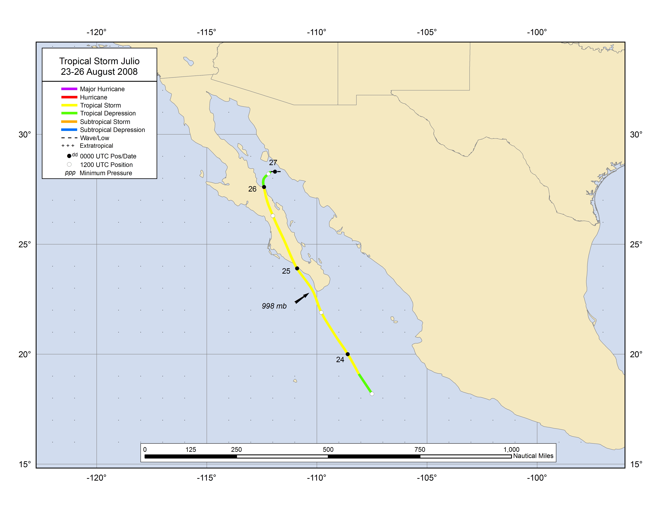
Figure 1. Best track positions for Tropical Storm Julio, 23-26 August 2008.
Figure 2. Selected wind observations and best track maximum sustained surface wind speed curve for Tropical Storm Julio, 23-26 August 2008. Dashed vertical lines correspond to 0000 UTC. Landfall in southern Baja California is indicated by the thin solid vertical line.
Figure 3. Selected pressure observations and best track minimum central pressure curve for Tropical Storm Julio, 23-26 August 2008. Dashed vertical lines correspond to 0000 UTC. Landfall in southern Baja California is indicated by the thin solid vertical line.

A digital record of the complete best track, including wind radii, can be found on line at ftp://ftp.nhc.noaa.gov/atcf. Data for the current year’s storms are located in the btk directory, while previous years’ data are located in the archive directory.

